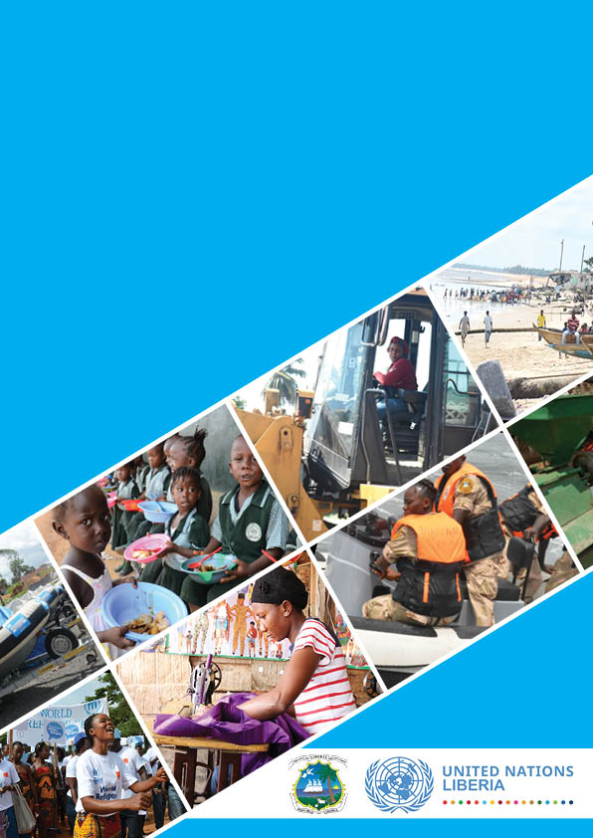
UNITED NATIONS SUSTAINABLE DEVELOPMENT COOPERATION FRAMEWORK
2020 - 2024

Table of Content
Executive Summary
UNLPF Preamble and Joint statement if of commitment
UNCT Signature
Abbreviations
- Introduction
  - The United Nations in Liberia
  - Rational for UNLPF 2020 2024
  - The UNLPF Development Process
  - Country Development Context
- UNLPF 2020-2024 Strategic Priority Areas
  - Principles and approaches for integrated Programming
  - Expected Outcomes
Strategic Priority I: Power to the people
Strategic Priority II: Economy and Jobs
Strategic Priority III: Sustaining Peace
Strategic Priority IV: Governance and Transparency
  - Risks and Assumptions
- Common Budgetary Framework
  - Resource Requirement for UNLPF 2020-2014 by Outcome
  - Resource Mobilization Strategy
- Implementation Arrangements
- Monitoring and Evaluation
- Communication of Results
Annex A: UNLPF Resource and Results Framework
Annex B: Calendar of Monitoring and Evaluation
Annex C: Indicative Costed Monitoring and Evaluation Plan

UNDAF Preamble and Joint statement of commitment

The Government of Liberia and the United Nations in Liberia are committed towards the achievement of the United Nations Vision 2030 and the Medium-Term Development Plan- the Pro-Poor Agenda for Prosperity and Development (PAPD). This Liberia United Nations Sustainable Development Cooperation Framework (UNSDCF 2020-2024) builds on the key lessons from the previous UNDAF (2013-2017) End of Programme Evaluation, the Common Country Assessment for Liberia (CCA), the United Nations System in Liberia Capacity Mapping Recommendations, the Integrated Transition Plan and the experiences from the UN Mission transition and the joint programming in previous UNDAF. The Sustainable Development Cooperation Framework reinforces commitment towards realization of the Seventeen Sustainable Development Goals (SDGs) and other regional and internationally agreed development frameworks and treaty obligations. The cooperation framework will guide the work and collaboration of the Government of Liberia and the United Nations as envisaged in the UN vision 2030- “To support Liberia become a reconciled, transformed and prosperous nation anchored on accountable institutions and equitable, inclusive and sustainable development”.
The cooperation framework will focus on the following broad strategic priorities- all aligned to the Pro-Poor Agenda for Prosperity and Development (PAPD-2018-2023) and the SDGs:
- Human Develop and Essential Social Services: Improved rights-based, gender sensitive quality life with inclusive, equitable access and utilization of essential social services- aligned to PAPD Power to the People Pillar;
- Sustainable Economic Development: Diversified and inclusive economic growth; sustainable agriculture, food security, job creation; and resilience to climate change and natural disasters- aligned to PAPD Economy and Jobs;
- Sustaining Peace, Security and Rule of Law: Consolidated and sustainable peace; enhanced social cohesion, rule of law and human right- aligned to PAPD Pillar Sustaining Peace.
- Governance and Transparency: Good governance; transparent and strengthened institutions to the delivery essential services targeting the most marginalized vulnerable
These four strategic priorities will support change and progress in Liberia resulting to a peaceful, healthy, empowered and productive nation. This strategic cooperation framework presents a mutual accountability framework between the Government of Liberia and the UN Country Team.

On behalf of Government of Liberia On behalf of the UN System in Liberia
Mr. Samuel Tweah Mr. Yacoub El Hillo

___________________________________ _____________________________

Executive Summary (to done after the last)

UNCT Signature

Abbreviations
AfDB - African Development Bank
CCA - Common Country Assessment
CEDAW - Convention on the Elimination of All Forms of Discrimination against Women
CFSVA - Comprehensive Food and Nutrition Vulnerability Assessment
EMIS - Education Information System
CSOs - Civil Society Organizations.
DaO - Delivering as One
DFID - Department for International Development
DRM - Disaster Risk Management
DRR - Disaster Risk Reduction
ECD - Early Childhood Development
EU - European Union
FAO - Food and Agriculture Organization
FGM - Female Genital Mutilation.
FNSS - Food and Nutrition Security Strategy.
GAM - Global Acute Malnutrition
GBV - Gender Based Violence
GDP - Gross Domestic Product
GNI - Gross National Income
GoL - Government of Liberia
HDI - Human Development Index
HIV/AIDS - Human Immunodeficiency Virus/Acquired Immunodeficiency Syndrome.
HRBA - Human Rights-based Approach
ICT - Information and Communication Technology
ILO - International Labour Organization.
IOM - International Organization for Migration
JICA - Japan International Cooperation Agency.
LISGIS - Liberia Institute of Statistics and Geo-Information Services
LUNPF - Liberia United Nations Partnership Framework
LNOB - Leaving no one behind
M&E - Monitoring and Evaluation
MDAs - Ministries, Departments and Agencies
MDGs - Millennium Development Goals
MoH - Ministry of Health
MPI - Multidimensional Poverty Index
MSME - Micro, Small and Medium Enterprises
MTP - Medium Term Plan
NAC - National AIDS Control Commission
NDMA - National Drought Management Authority
NGOs - Non-Governmental Organizations
OHCHR - Office of the United Nations High Commissioner for Human Rights
PPP - Public Private Partnership
SDGs - Sustainable Development Goals
Sida - Swedish International Cooperation Agency
ToC - Theory of Change
TVET - Technical and Vocational Education and Training
UHC - Universal Health Care
UN - United Nations
UNCG - United Nations Communication Group
UNCT - United Nations Country Team
UN Habitat - United Nations Agency for Human Settlements
UN Women - The United Nations Entity for Gender Equality and the Empowerment of Women
UNAIDS - United Nations Programme on HIV/AIDS
UNDAF - United Nations Development Assistance Framework
UNDP - United Nations Development Programme
UNESCO - United Nations Educational, Scientific and Cultural Organization
UNFPA - United Nations Population Fund
UNHCR - United Nations High Commissioner for Refugees
UNICEF - United Nations Children’s Fund
UNIDO - United Nations Industrial Development Organization
UNISDR - United Nations Office for Disaster Risk Reduction
UNODC - United Nations Office on Drugs and Crime
UNSD - United Nations Statistics Division
UNV - United Nations Volunteers
UPR - Universal Periodic Review
USAID - United States Agency for International Development
WASH - Water, Sanitation and Hygiene

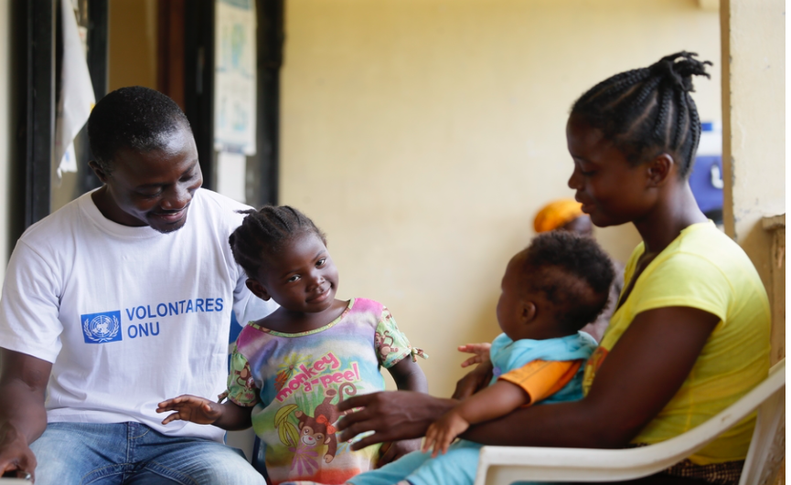

- INTRODUCTION

1.1. The United Nations in Liberia
The United Nations in Liberia consists of Twenty-One Agencies, Funds and Programmes and Non- Resident Agencies including African Development Bank and the World Bank Group.
The United Nations in Liberia supported the Government of Liberia in the development of the Pro- Poor Agenda for Prosperity and Development (PAPD 2018-2023) that is a country-owned and led pathway out of fragility, with a commitment of building mutual trust by providing one Vision, one Plan and alignment of resource effectiveness for results. The United Nations Assistance Development Framework (2013-2017) was extended to December 2019 to ensure alignment with the new administration’s national agenda, the PAPD. The Pro- Poor Agenda for Prosperity and Development was launched in October 2018, that subsequently guided the development of the UNSDCF.

A part of the process for the development of this cooperation framework, the UN in Liberia undertook a Capacity Mapping exercise that provided an evidence base for calibrating a response that would ensure the UN remained fit for purpose to continued support the reconciliation and peace consolidation during the transition and post-United Nations Mission in Liberia (UNMIL) phase given the challenges of fragility in Liberia’s and in the region. Further, UN undertook the Common Country Analysis (CCA) to assist in informing priority settings for the UN Vision 2030 and provide evidence in the development of the Theory of Change for the cooperation framework of support for the Government of Liberia.

The implementation of the previous UNDAF (2013-2017), was adversely affected by Ebola Viral Diseases (EVD) outbreak with a shift of programme focus to emergency response between March 2014 and April 2016. The EVD emergency response slowed down and reversed some of the gains that had been made in development indicators and adversely devastated the health care system in the country. Prior to the EVD outbreak, the
Human Development
Liberia is one of the poorest countries in the world ranked 4th of the 30 poorest countries. The 2013 multi-dimensional poverty values for Liberia reflected that the majority of people in Liberia were experiencing multi-dimensional poverty. Liberia’s multi-dimensional poverty index for 2013 showed that 70% of the population were multi-dimensionally poor. The incidence of poverty is estimated to have increased from 54.1% in 2014 to 61.2% in 2016. Rural poverty was higher at 76.1% compared to urban poverty at 31.5%. Male-headed households (MHH) had absolute poverty at 53.3% compared to 46.3% for female headed households (FHH). The Gini Coefficient which measures inequality was 0.33 at national level, 0.32 in urban areas and 0.27 in rural areas.
Liberia which is recovering from the effects of the Ebola crisis, is currently facing low commodity prices, especially from the extractive industry which has been the main drivers of economic development over the years. The economy is further constrained with major structural dysfunctions including small-scale agricultural production and low productivity is low; coupled with financial and human capacity constraints. These challenges are compounded by low capacities in the security and rule of law sectors, slow progress in national reconciliation and implementing critical Government reforms. In the absence complete national reconciliation and compounded by poor public confidence in institutions. National institutions are highly centralized with very limited presence outside of Monrovia that has hampered development efforts in Liberia.
Sustaining peace in Liberia requires long-term investment in national institutions that are inclusive, accountable, and responsive, with a government that is committed to providing equal opportunities and services to all Liberians; especially those vulnerable and or marginalized. The UN in partnership with Development Partners, CSOs and the Private Sector will support the Government and partners in strengthening national and devolved institutions to delivery essential services at local level.
Liberia conducted Presidential elections October 2017, and a run-off in December 2017 that ushered in a new administration led by H.E President George Manneh Weah in January 2018. The UN Mission departed Liberia in March 2018, and with its departure, a seamless transition to the UN Country Team ensuring the UN’s continued presence in the Liberia focused on sustaining peace and development. The transition and withdrawal of the UNMIL resulted in a reduced UN foot-print in Liberia. The UN Country Team supported the new government in developing its national pro-poor agenda for sustaining peace and development.
The Government of Liberia’s Pro-Poor Agenda for Prosperity and Development (PAPD) is a five-year Strategy designed to accelerate inclusive and sustainable development and is premised on four pillars that are inter-connected and mutually reinforcing. Pillar one - “Power to the People” is founded on the belief that the foundation of human development is health and education supported by programs which reduce vulnerability, particularly among women, children and youth. Pillar two: “Economy and Jobs” focuses on raising the productivity and income of every Liberian worker by creating an appropriate policy setting, enhancing competitiveness, and extending and upgrading the nation’s infrastructure. Pillar three – “Sustaining the peace” addresses the root causes of conflict and fragility by ensuring that the human rights of all Liberians are protected by the rule of law and broad-based access to justice. Pillar four – “Governance and Accountability” – highlights the capacity of the state to honestly, competently, and efficiently fulfill its responsibilities to all Liberians.

Figure 1: The Pro-Poor Agenda for Prosperity and Development in a Glance.
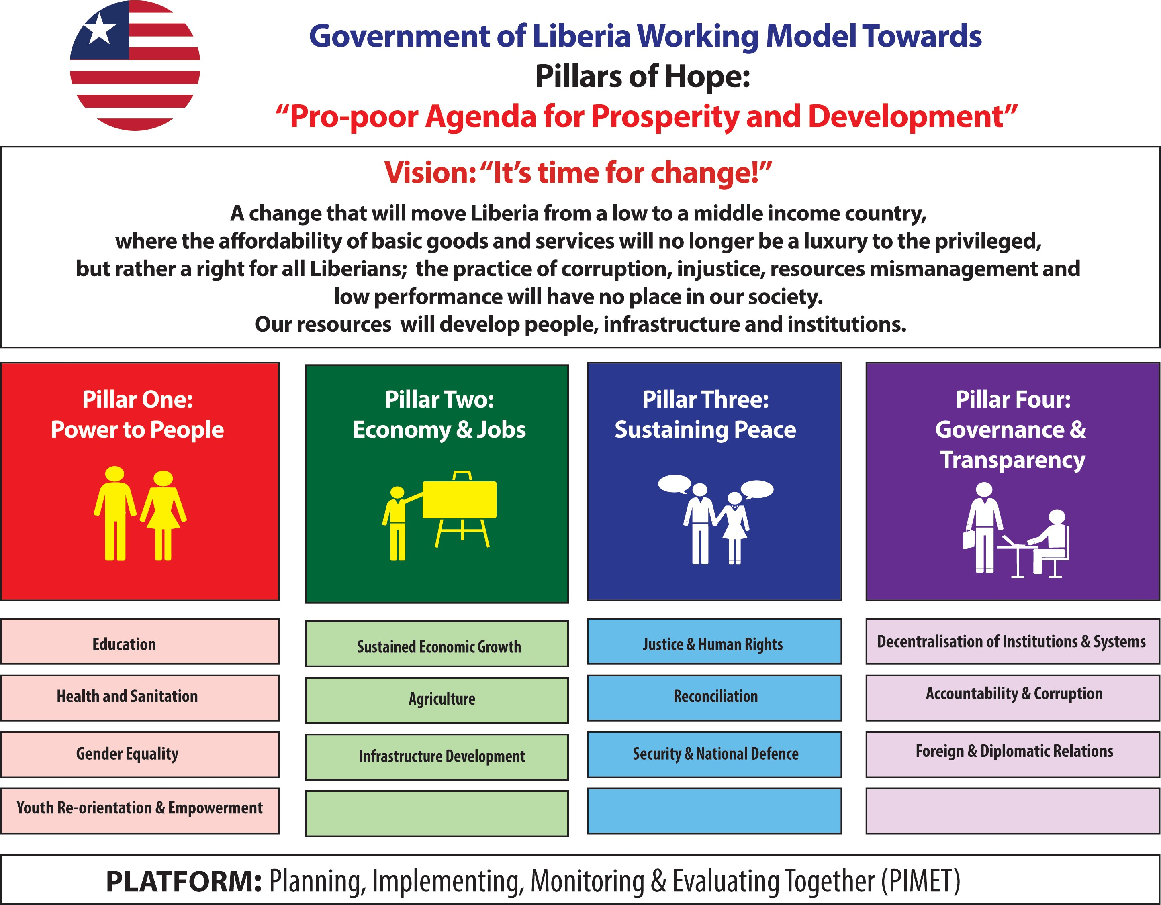

Rational for LUNPF 2020 2024
The Government of Liberia’s Vision is to “to build more capable and trusted state institutions that will lead to a stable, resilient, and inclusive nation embracing its triple heritage and anchored on its African identity and to provide greater income security to an additional one million Liberians, and reduce absolute poverty by 23 percent across 5 out of 6 regions--through sustained and inclusive economic growth driven by scaled-up investments in agriculture, infrastructure, human resource development, and social protection. The Vision is anchored on four key pillars: Power to the People; Economy and Jobs; sustaining Peace; Governance and Transparency. This new generation of Partnership Framework (20120-2024) for Liberia is aligned the national Pro-Poor Agenda for Prosperity and Development, and the national Vision is aligned to the Africa Agenda 2063 and the Economic Community of West African States (ECOWAS)Vision 2020.

Figure 2: LUNSDCF 2020-2024 Alignment to the national development Priorities
LUSDCF 2020 – 2024 Alignment to National Development Priorities and Implementation Framework
Strategic Alignment to National Development Priorities
- Vision 2030
- Pro Poor Agenda for Prosperity and Development (PAPD)
Power to the People
Economy and Jobs
Sustaining the Peace
Governance & transparency
GoL/UN Annual workplan
Joint implementation with GoL and Sector working groups
Joint Programme
(Spotlight, SGVB,
Monitoring and Evaluation, Innovation, Data Management,
Decentralization and
Sustainable Development Goals (SDGs) Domestication and implementation
Partnership with Development Partners, stakeholders, private sectors

The UNLPF Development Process
Liberia’s new Government Administration took office on January 2018, and immediately outlined its development programme, the Pro-Poor Agenda for Prosperity and Development (PAPD). This development plan covers the period: 2018 – 2023 and was launched in October 2018 by the President of Liberia. The United Nations Country Team (UNCT) Cooperating and Development Partners supported the Government of Liberia in the development of the Medium-Term Strategy that lays the foundation of transforming the country into a prosperous, stable and resilient nation. The PAPD requires commitment, extreme and broad ownership for its successful implementation, while also requiring mutual accountability of all parties.

The UN in Liberia aligned to the PAPD framework, in the design of the UN Sustainable Development Partnership Framework, and coalesced around the four Pillar Result Groups that mirror the those of the PAPD.

As part of the UNSDCF development process, the UNSDCF Roll Out Road Map endorsed by the UN Country Team and the Government of Liberia at a joint Steering Committee in 2018. The UNDAF 2013-2017 End of Programme Evaluation was conducted and its recommendations inform the development of this UNSDCF. The Common Country Assessment (CCA) was conducted in in June 2018, and endorsed by the Government of Liberia and the UN Country Team. The CCA has guided the development of this UNSDCF. The UN commenced the development of the UNSDCF with the launch of the PAPD to ensure alignment to the national medium-term framework. A series of stakeholder consultations were held with all stakeholders- Government of Liberia, Development Partners, Civil Society Organizations, INGOs, Traditional and faith-based institutions and the Private Sector. A series of internal UN consultations were also conducted in identifying the strategic priority areas of the UN in support of the GoL PAPD. This included internal UN Pillar consultations, UN Vision Retreat, Joint UN Steering Committee, Strategic Prioritization Retreat and the UN System wide training to ensure that critical programming principles are considered.

The UNSDCF builds on past lessons, considers emerging realities of a fragile Liberia, builds on the UNCT strengths and opportunities with the departure of UNMIL and is guided by the UN Global reforms, to identify and develop focused and realistic strategic interventions in support of the priorities of the Government. The aspiration ensured that the new UNSDCF is grounded in the national realities, owned by all the parties and is useful in driving the development agenda.

Country Development Context

Poverty Trends
Liberia is a least-developed, low-income country that has sustained peace since the Peace Accord was signed in 2003. It is estimated to have a population of approximately 4.6 million people. It is ranked 177 out of 188 countries on the 2016 United Nations Development Programme (UNDP) Human Development Index, and 150th out of 159 countries on the Gender Inequality Index (UNDP HDR 2016). Poverty is pervasive with over 70 percent of the population living in poverty.

The 2013 multidimensional values for Liberia reflect the majority of people experiencing multi-dimensional poverty: In 2010, Human Development Reports (HDRs) introduced a concept of multidimensional poverty index (MPI), which identifies multi-deprivations suffered by households in three (3) dimensions- education, health, and living standards. Liberia’s MPI for 2013 indicated that 70% of the Liberian population constituting 3,010,000 people were multi-dimensionally poor, while an additional 21.5% lived near multidimensional poverty (924,000). The intensity of deprivations in Liberia reflecting the average deprivation score of people in multi-dimensional poverty is 50.8 percent. Further, people living above the income poverty line may still suffer deprivations in education, health and other living conditions. As of 2016 Liberia’s income poverty stood at 50.9%, with higher intensity of poverty for people living in rural areas, male-headed households and predominantly agricultural sub-population groups: The 2016 Households and Income Expenditure Survey (HIES) indicated that nearly half of the Liberia’s population is poor (50.9%). Rural poverty is higher at 76.1% compared to urban poverty at 31.5%.
Economic Overview
Liberia is one of the poorest countries in the world. On the ranking of the 30 poorest countries in the world, Liberia sits on the fourth position with a Gross Domestic Product (GDP) of USD 882. Over the years since 2013, the country has experienced GDP fluctuations. Its economic growth fell to nearly zero since 2014, when the country was hit by Ebola Virus Disease (EVD) crisis and by falling international prices for rubber and iron ore, its two key exports. Since the end of the Ebola outbreak in 2014-2015, almost all economic and sub-sectorial reviews of Liberia’s developmental performance have experienced slow growth. Inflation has remained at double digit (27%) since December 2018 and with declining livelihood options, the inflationary forces are likely to be sustained for in the foreseeable future.
After real GDP growth of 0.7 % in 2014 and 0% in 2015, the country contracted to an estimated -0.5% in 2016. Liberia’s economy is market-based and largely dependent on natural resources, foreign aid and foreign direct investment. The economic impact of the 2014 Ebola Virus Disease (EVD) outbreak was compounded by a sustained decline in global iron ore and rubber prices, which negatively affected exports and new investment in these sectors. The IMF estimated real GDP growth in 2016 was negative 1.2 percent, with an annual inflation rate of 12.5 percent. Liberia’s exports were valued at $169.6 million at end-2016; the export sector relies heavily on rubber and iron ore which accounted for 64 percent of total exports in 2016. Liberia’s macroeconomic risks are rooted in structural economic imbalances: a highly-concentrated export and fiscal revenue base, a heavy reliance on foreign aid, and over-dependence on food imports.

Key challenges for sustainable economic development:
Liberia experiences high inflation. In 2018 inflation averaged 12.5% compared to 8.5% in 2017 (World Bank 2018). The growth evidence shows an increase in external debt stock, which rose from USD 597 million in September 2016 to USD 736 million in June 2017. Liberia’s economy is characterized by high importation dependency. The country is experiencing high national expenditure which is not conducive for sustainable economic growth. It has an under-developed formal employment sector with low national employment rates.
The country anticipates to raise Real GDP growth from 3.2% in 2018 to 5.8% in 2023 with major drivers of growth underpinned by robust fiscal and monetary; and foreign exchange reforms, to create the right policy environment, improve the doing business environment, increase competitiveness through investments in real growth-enabling sectors mainly agriculture and fisheries, forestry and service sectors; and by investments in reducing infrastructure deficits using approaches that are more labor-intensive and use more local content.

Increased indebtedness/ growth of debt stock: Statistical evidence show an increase in debt stock. The external debt stock had been increasing partially due to scaled-up infrastructure spending and multiple adverse shocks. Micro-economic risks were high as a result of: i) an open economy heavily dependent on foreign aid, ii) high dependency on foreign direct investment (FDI) and primary exports. The country is also dependent on imported fuel and food which makes it vulnerable to shocks with both fiscal and balance of payments implications. From September 2016 to June 2017, the total debt stock increased from USD 597 million to USD 736 million. External debt stock comprised mostly of multilateral loans.

Liberia experiences high national expenditure not conducive to sustainable economic growth: Analysis of data generated from multi-stakeholder consultations (government, private sector development partners and the UN) reiterated the high expenditure patterns which might become an obstacle to sustainable economic growth. The Social Cohesion Study policy brief on the Liberia economy also confirms this development challenge. The policy brief highlighted that the national expenditure pattern of the country (consumption and investment) far much exceeded the gross domestic product (GDP), resulting in the chronic current account balance and pressure on the exchange rate. Evidence from the United Nations Conference on Trade Data (UNCTAD) in 2015 shows that the final consumption expenditure and investment exceeded the GDP by 57%.

Liberia has an underdeveloped formal employment sector with a low national employment rate: The country has 20.1% national formal employment rate. The labor force is characterized by informality and vulnerability. According to the HIES (2016) 79.5% of workers are found in what are described as vulnerable employment jobs while another 79.9% are found in the informal employment. Unemployment is 3.9%. About 58% of the active workforce is literate but largely unskilled, or, semi-skilled. Employment is largely concentrated in the agriculture sector constituting half of the total employment and employed around three quarters among the rural population. over 90% of youths did not have access to formal employment. Women experience much higher informal employment at 90.9% and vulnerable employment at 91.1%.

HUMAN DEVELOPMENT
Liberia’s Human Development Index (HDI) and Inequality-adjusted Human Development Index (IHDI) remain low compared to regional and sub-regional averages: Liberia’s HDI value for 2015 was 0.427, placing the country in the low human development category and also positioning it at 177 out of 188 countries. Despite the seemingly improving HDI for Liberia since 2013, the 2015 HDI of 0.427 was below the average of 0.427 for countries in the low human development groups and also below the 0.523 for countries in Sub-Sahara Africa. Further, Liberia’s HDI for 2015, when adjusted for inequalities (IHDI) fell further to a value of 0.284, a loss of 33.4%.

Health: Child survival remains below the expected level. The rate of neo-natal mortality in 2013 was 38/1 000 live births, infant mortality rate was 54/1 000 while under five mortality stood at 94/1 000 live births. Overall Liberia has high stunting levels, with national average at 32 per cent (Liberia Demographic Health Survey (LDHS 2013). Stunting levels vary little residence with urban areas at 30 per cent while rural areas are 33 per cent (LDHS 2013 p.160/161). One of the key drivers of undernutrition in Liberia is the sub optimal feeding practices among children under five years. The exclusive breastfeeding rate among children 0-6 months is 55 per cent

Nutrition: One of the major factors inhibiting the survival and optimal development of children in Liberia is the high prevalence of stunting, which affects one third of all children under 5. Liberia has made some progress towards reducing stunting in the last decade, with a reduction of 13 percentage points from 2000 to 2013, from 45 to 32 per cent (2013 LDHS). Another 6 per cent of Liberian children suffer from acute malnutrition, as manifested by wasting (low weight for height). Fifteen per cent of Liberian children are considered underweight for their age. The key drivers of malnutrition in Liberia are disease, sub optimal child feeding practices and household food insecurity. The most common preventable diseases affecting under five children include malaria, diarrhea and pneumonia.

Household food insecurity. An estimated 18 per cent of Liberians are food insecure and 2 per cent are severely food insecure (Liberia Food Security Assessment, 2015). This means that households end up consuming foods that are inadequate in quantity and quality. Children are more sensitive to short-term foods shortages and this pushes them into malnutrition.

Malnutrition rates vary little by area of residence with 30 per cent in urban areas and 33 per cent in rural areas. The prevalence of stunting, wasting, and underweight is inversely correlated with wealth quantile. Children in the highest wealth quantile are less likely to suffer from malnutrition than those in lower wealth quantiles. The prevalence of overweight children varies little by background characteristics.

Immunization Coverage: Realization of universal immunization coverage in Liberia is very difficult due to inadequate access to health facilities by underserved and remote communities, and the country continues to have pockets of measles outbreaks among children above 5 years of age.

Maternal Mortality: Despite improvement in services for pregnant mothers, maternal mortality in Liberia still remain at unacceptable levels: Although the proportion of births attended by health workers increased from 40% in 2007 to 61% in 2013, this fell back to 51% in 2015/16, particularly due to low utilization of health services in post-Ebola period. This limited progress on maternal mortality rate which at 1072/100 000 live births in 2013, was one of the highest in the world.

HIV and AIDS: HIV prevalence rates are noted to be increasing with variations by sex, sub-population groups and geographical location. The 2013 LDHS noted that Liberia had a generalized HIV epidemic with a nation HIV prevalence of 2.1%. The prevalence was higher among women at 2.4% especially those above 20 years compared to males (1.8%). Key populations were disproportionally impacted by the epidemic because of their high-risk behavior. The national prevalence is at 2.1%. It is higher among women at 2.4% compared to males 1.8%. The prevalence rate is slightly higher in urban areas (2.6%) compared to rural areas (0.8%

Health Systems Strengthening: The country’s capacity to respond to public health threats has been strengthened, mainly prompted by the need to control the Ebola Virus Disease (EVD). Patient screening for infectious diseases has improved. National diagnostic capacity for public health diseases has improved the capacity of the country to diagnose six (6) priority diseases of epidemic potential. The challenges in the health sector include ; a) The Ebola outbreak exposed the health system structural vulnerabilities, including shortage of qualified health care workers, a weak incentive system, inadequate infrastructure and unpredictable donor-driven financing’ Liberia’s Performance on selected WHO standards in the health sector was below expectation: SARA revealed that Liberia’s health facilities density (facility per 10, 000 person) is 1.7 lower than WHO standards at 2/10,000. The health workforce was 11/10,000 population against WHO recommended 23/10,000. Access to health services was still inadequate in some rural or remote communities; b) Exceptionally high maternal and neonatal mortalities rates in Liberia; c) Supply chain gaps with shortage of medicines and medical supplies in health facilities; d) Inadequate qualified health workers to meet the health needs of the population; e) demotivated health workers due to low salaries, lack of accommodation, job insecurity and inadequate allocation to the Ministry to facilitate additional health workers on GoL payroll. (Contract employees that were paid by partners)

Education: Average educational enrolment is significantly low at all levels of the Liberian education system. At ECE level, 61% of the children are usually above the official pre-primary school age and more than three years older than the age considered to be appropriate. For primary education, as of 2017 the net enrolment rate (NER) stood at 45% while that for the senior high school was at 62% in 2015. The total Liberian population with tertiary education currently stands at 10.4%. Literacy levels in the country vary along gender, social status and geographical location. Male literacy is currently at 77% while female’s is less than 54%. There are also differences according to location. About 47% of the rural youth reach the 6th grade as compared to 88% of the same age group in urban areas. Social status which determines economic muscle has an impact on educational attainment. The wealthy groups can afford private schools and mission schools as compared to poorer classes. In an effort to improve the education sector, the Liberian government has opened avenues for partnerships.

Average educational enrolment was significantly low at all levels of the Liberian education system: As of 2012, overall gross enrolment rates (GER) for Early Childhood education (ECE) was 122% (125% for boys and 118% for girls). By 2016, over 36% of early childhood education (ECE) students were more than three years older than the age considered to be appropriate for the grade in which they were Geographical location which usually determines economic muscle played a part in educational survival. Children from rural and poorer households were less likely to survive to grade 9 and attain basic education as compared to children in urban setting who were relatively wealthier enrolled. As of 2017 45% were enrolled in primary education (41.4- boys and 50.4 girls).

The Education Sector is characterized by several challenges:
- The education system has inadequate inputs (teachers, trained teachers, infrastructure and text books) for effective and efficient service delivery- unequally distributed. According to Ministry of Education (2016) the range of student-qualified teacher ratio was from 33.8 to 90.0 with a mean of 43.5. The student teacher ratio (across all school and levels of education) varied from 21.1 to 40.6 with a mean of 27.0. There were high numbers of untrained teachers, inadequate infrastructure in schools which led to overcrowding;
- The Liberian education system is not inclusive, with the majority of Liberian children and youth vulnerable and facing various forms of exclusion that affects access to quality education. Several social and economic factors contributed to the vulnerability of Liberian children and youth, including extreme poverty and other external shocks. The vulnerability coupled with other variables of disadvantage and disparity such as rural status, being in a household where the head had low educational attainment, contributed to some children not accessing education. Poor and most rural families could not afford private and mission schools which were more clearly, meant for the elite.
- The education sector was characterized by poor infrastructure, equipment and weak foundational skills. Many institutions were too small to achieve economies of scale, thereby increasing costs and compromising quality. There was no national quality assurance, or, accreditation system, or, any process for international or regional peer review. Due to poor learning outcomes in lower levels of education, high school graduates were generally incapable of handling the advanced educational programmes. In 2013, nearly 25,000 school leavers failed the admission test at the University of Liberia.

Gender Equality
Women and girls account for 49 percent of Liberia’s population (UN WOMEN 2016). The fertility rate is 4.9 children per woman (United Nations Children Fund [UNICEF], 2012) with 35 percent of households headed by women (Demographic Health Survey [DHS], 2013). Women and girls face entrenched and pervasive barriers that limit their ability to realize their full potential in society, including participation in the political, economic and social domains.
Agriculture
While the Government projects that the agriculture sector, will be the main job and wealth creation source for the majority of youth, the sector remains constrained with low production and productivity in all commodities except the tree crops. The country has remained a net importer of food. According to the CCA 2018, Liberia’s macroeconomic risks are rooted in structural economic imbalances: a highly-concentrated export and fiscal revenue base, a heavy reliance on foreign aid, and over-dependence on food imports”. Unemployment especially amongst the youth. and the challenges of natural resources management have been identified as priority areas deserving urgent attention. Hence, in view of the national re-growth following the crisis of recent past, and the need to exploit the vast potential of the nation for the benefit of the people, both the CCA and PAPD recommend that job creation and environmentally sustainable exploitation of Liberia’s natural resources be given priority.

In consonance with these broad priority areas therefore, thematic area Theory of Change is to (as expected under the PAPD) put “agriculture sector as the major driver of growth and development” and in the process pursue the attainment of achieving sustainable food security, job creation, sound natural resources management in an inclusive manner (leaving no one behind), with particular attention given to the needs of the vulnerable and resource poor households. The latter group form the majority of Liberia’s population, live in the rural areas have the highest absolute, food and extreme poverty rates. With poor infrastructure, the rural populace would also bear the brunt of population growth and its associated challenges.

Challenges remain in sustainable inclusive growth, shared prosperity, governance, peace and security, sustainable environment and natural resources management, climate change and resilience to shocks. Critical challenges facing Liberia are high levels of poverty and inequality. Exclusion of the poorest and vulnerable, especially people in the rural areas and informal settlements remains a grave concern. A wide urban-rural gap exists in terms of access to education, electricity, water and sanitation, health and housing services, which exacerbate inequalities in income and livelihood opportunities. The underlying causes of poverty in rural areas include low investment and low agricultural productivity reinforced by agro-climatic shocks that impact vulnerable communities that rely on rain-fed agriculture.
The Multidimensional Poverty Index (MPI) shows a higher incidence of poverty of 50.9 percent with 63 % percent of the population in severe multi-dimensional poverty. come inequality levels have not decreased significantly in recent years and achieving inclusive growth remains a development challenge. Liberia ’s Gini coefficient of 0.33 is below the Sub-Saharan Africa 2013 average of 0.43
Furthermore, poverty is feminized. Poverty incidence among women tends to be higher than men in many dimensions that include minimal employment opportunities in the formal sector and earning overall lower wages. The female labour participation rate (53.3 percent) is lower than the male labour participation rate (59.4 percent)
Equal rights for men and women to own land still remains a challenge with women owning 38% of agricultural land and rarely accessing available credit. This is despite the fact that women provide over 80 per cent of farm labour and manage 23 per cent of Liberia ’s smallholder farms. In 2017/18, the Gender Inequality Index ranked Liberia 155 of 160 countries with a score of 0.656, illustrating significant gender gaps in human development.
Unemployment stands at 2.42 percent with female constituting 2.38 percent of the unemployed; as such, there is pressure for job creation and skills match in the labour market. Liberia requires appropriate policies to spur the growth of the formal sector economy and equip people with relevant and in demand skills to create productive jobs. The magnitude of the problem underscores the need to focus on spurring growth in the productive sectors including agriculture, extractives, manufacturing, trade, and tourism, all which have enormous potential for employment creation and structural economic transformation.
Governance:
Liberia’s governance ranked 54.1 on the Ibrahim’s Index of African Governance and 28 out of 54 African countries. Liberia’s governance ranked 54.1 on the Ibrahim’s Index of African Governance and 28 out of 54 African countries. Overall, Liberia was ranked 28th out of 54 African countries on good governance with respect to the following: (i) Safety and the Rule of Law (19th); (ii) Participation and Human Rights (18th); (iii) Sustainable Economic Opportunities (36th); and (iv) Human Development (44th). Of the 40 countries that had shown improvement in overall governance over the last 5 and 10 years (2007-2016), Liberia was joint best 5th, increasing its score by +18 per year average in the last 5 years and + 72 in the last 10 years. The areas of Human Development and Sustainable Social Economic Opportunities continue to lag behind, with the country ranked 44 and 36 respectively out of 54 Africa countries. The 2018 Mo Ibrahim Index on Governance in Africa ranked Liberia 24/54 with a score of 56.6/100 with improvement in rule law (61.4 Per cent) with a number of areas that require improvement, namely sustainable economic transformation (39 percent),
Fragility, Peace and Reconciliation
While progress had been made in the areas of governance, vulnerability in Liberia remains high. Liberia was still struggling with ethnic, religious, gender driven and class-based polarization. There are high levels of mistrust, especially due to issues of bad governance that pre-dated the war. A study in 2016 by the Catholic Relief Services observed that potential triggers of conflict included corruption (85.9%); land disputes (83.7%) and high youth unemployment (79%). The social fissures were worsened by high rates of unemployment. Liberia youth had scanty professional training, or, employable skills for the job market. According to SCORE, the country average score for aggression was 2.7. The SCORE (2017) noted that 57% of Liberians shared generally peaceful attitudes while 14% held the opinion that aggression was a necessary tool to address community disagreements. The national average for political tribalism score was 3.0 on a scale 0 (no political tribalism) to 10 (strong political tribalism).
The root causes of civil war remain unaddressed. Despite the gains made in maintaining national peace and security, the root causes of the country’s 14-year civil war, remained unaddressed. The triggers of conflict include: a) an unfinished business of peace and reconciliation and a slow national reconciliation process. There remains the need for a deep-seated, community-based and internally-driven reconciliation process remained a major gap for the effective healing of post-war atrocities; b) grievances over the political legitimacy of concessional agreements, given the failure of contractual processes to involve the affected communities and local authorities in decision making when granting concessions and a lack of government accountability for ensuring good conduct by the concessionaries; effective delivery of national legislative agenda issues, land disputes, corruption, county boundary disputes and concession related tensions. Pending constitutional review as this would address the inherent inequalities embedded in it; slow implementation of critical government reforms.

Public Sector Reform
The World Bank and the AfDB, supported the government enactment of the PFM Act in 2009, to strengthen greater transparency and accountability. A 2008 survey for Liberia on PFM reported that 32% of Aid made use of PFM systems. Very few donors channeled funds completely through the country’s PFM system due to concerns about the strengths fiduciary controls and low government implementation capacity. Most projects are stand-alone projects and they do not rely on government financial management and procurement systems. The World Bank set up PMF Unit with the Ministry of Finance. The establishment of the Public Procurement Commission in 2006 has contributed to some progress. But despite some progress, the understanding of PFM programmes and normal operational procedures as seen in the PFM operational manual remains low within the new administration. Weak government capacity to manage procurement processes remains an issue. Many ministries currently under-spend due to poor procurement capacity and oversight.

Civil Service Capacity
The civil service continues to have huge challenges that are associated with weak payroll compliance, relatively low salaries, poor alignment between skills and functions. A Liberia government document noted key challenges of the civil service as belonging to three broad categories: i) Not regulated, ii) Low performance and wages; Mismatch between positions grade and remuneration and also lack of job descriptions; Low capacity and productivity. The report notes the existence of ghost workers, a bloated bureaucracy and inequity in pay.

There are government deficits in the delivery of public services. Liberia has a weak public service system and does not have a Civil Service Commission. Coupled with persistent systematic corruption and lack of accountability triggers low public confidence in the legitimacy of national governance. The quality and coverage of public services has not improved and in some areas economic conditions are deteriorating.
Decentralization
The future of decentralization in the country remains uncertain: All revenues generated by the CSCs continue to go to the central government coffers without retentions for building the CSCs’ own service capacity. Fiscal decentralization plan in Liberia is contingent on pending legislations.

Accountability and Transparency
There are ongoing structural inadequacies that reinforce poor governance: The new structures and frameworks created by the Government of Liberia to increase participation, accountability, transparency and service delivery suffer from capacity deficits in both the numbers of staff and trained staff. Access to physical resources needed to carry out intended functions was limited. There is endemic corruption, including nepotism and capture of government resources for personal gain.

Human Rights, Inequalities and Discrimination
Gender inequality transcends all spheres of life in Liberia. Despite women constituting a higher proportion of the population compared to men, development indices are negative for women. Women have limited participation in the economy, with 53% of women compared to 74% of men involved in gainful employment. Their participation in politics is equally low. In 2017 women held four (4) out of 19 ministerial positions. Human rights in Liberia are marred with rampant rape with impunity. Women also experience high levels of Sexual Gender Based Violence (SGBV) with statistics showing that in 2016, 1431 women reported SGBV cases. In 2016, 803 case of rape were reported with only 34 convictions being made. Female genital mutilation (FGM) is common and deeply rooted in society such that efforts by the government to stop the practice are met with resistance. In 2015, 11% of women aged 20-22 were married by age 15 and 23% were married by age 18, bringing in the concept of early and forced marriages. Adolescent girls especially, continue to experience various forms of deprivations (harmful traditional practices: Child marriage/ teenage pregnancy and gender norms) which often affect their capability to realize their aspirations in life. The country is part of the regional and international human rights community and has also put in motion processes to address human rights issues in the country, including prioritizing CEDAW reporting.

Gender Inequalities
Gender inequalities cut across all spheres of life in Liberia. Women are disproportionally represented in all areas of livelihoods with the inequalities giving rise to unequal gender power relations, lack of access to basic and productive services, under-representation in governance systems, lack of access to legal and judiciary services. The limited participation of women in all aspects of life contributes to poor development results characterized by poor performance in most development indicators.

The situation and status of women has not improved for the majority of women, particularly those in rural areas, in the post-conﬂict period. This is reﬂected in the 2012 Gender Inequality Index (GII) where Liberia was ranked 143 out of 148 countries (UNDP, 2013) and in the 2012 Social Institutions and Gender Index (SIGI) where Liberia was ranked 62 out of 86 countries (OECD, 2012). Liberia’s (Gender Inequality Index) GII had a value of 0,649 (where a rate closer to 0 is better performance while that closer to 1 is poor performance), ranking 150 out of 159 countries.

Gender Situation Analysis
Despite women constituting a higher proportion of the population compared to men, development indices were negative for women: Women constituted 51.5% of the population (HIES 2016). Liberia’s demographic statistics revealed high fertility rates (almost 5 children per woman) and a high adolescence birth rate of 109 births per 1000 of females in the ages 15 to 19. In 2010 the UNDP Human Development Reports (HDRs) introduced Gender Inequality Index (GII) which reflects gender-based inequalities in three areas of reproductive health, empowerment and economic activities. The 2014 female HDI value for Liberia was 0.387, compared with 0.491 for males, resulting in a GDI value of 0.789.GII can be interpreted as the loss of human development due to inequalities. Women had low literacy rate 54.8%. For young women aged 15-24 years, only 44% women were literate compared to 64.7% for young men in the same age groups. Cross cutting barriers to women’s education included: sexual gender-based violence, early marriages, teen pregnancies, rape of under-age girls and other forms of abuse in the school environment. ‘Sex for grade’ is not an uncommon expectation from teachers which negatively impedes the retention and completion of girls’ higher education.

There are gender disparities in women’s participation in the economy. About 53% of women compared to 74% of men are involved in gainful employment. Although women have made important contribution to the informal economy, and in the agriculture sector, they still experienced limited access to productive resources and services essential for investment in economic activities.

Participation of women in politics and governance structures remain low. Women are severely misrepresented within the legislature. As at 2017 status, women held 4 seats out 19 ministerial positions which constitute only 21%. In the senate, women occupy only 27 seats out of 90 while in the House of Representatives, men occupy 65 out of 75 seats constituting 89% representation by males. Representation of women in the security sector also continue to be a challenge with 20% representation in immigration and 17% in Liberia National Police (LNP). The Gender Empowerment Measure captures gender inequality in three key areas: the extent of women’s political participation and decision-making, economic participation and decision-making power and the power exerted by women over economic resources (Gender Empowerment Measure, 2016). From the review of national documents, and specifically the country’s National Gender Policy, women in Liberia experience gross inequalities in three areas monitored by the GEM. These put the country’s gender empowerment indicators among the lowest in the world.

Women experience high levels of SGBV in Liberia. In Liberia the percentage of women who have experienced violence was 41.2% of which 38.6% had been committed by intimate partners and 2.6% by others. According to the Ministry of Gender, Children and Social Protection (MOGCSP) (2017), on average 1400 women reported SGBV each year as follows: 2011 (2,383 cases); 2012 (2,493 cases); 2013 (2,159 cases); 2014 (1,359 cases); 2015(1,555 cases) and 2016 (1,431 cases). Institutions lack the capacity to provide a comprehensive and coordinated package of assistance to the survivors, including psychosocial counselling, access to adequate medical assistance, access to justice and the protection from perpetrators. Men constitute 2% of reported victims of SGBV.

Human Rights

Rape: Liberia was part of the international community that participated in Universal Periodic Review (UPR) processes, therefore, reaffirmed her commitment to the protection of the promotion of human rights. It had a UPR report covering 2010 to 2014. The UN Human Rights Police Services (HRPS) reported that the cases of rape in Liberia were extremely high. It was the most commonly reported crime in the country. In 2014 according to the MOGCSP, 708 cases of rape were reported, including gang rapes. Survivors of rape often did not get access to justice. In 2015 the number rose to 803. Of the 1,511 cases, only 836 were registered by the police and of this figure, only 259 cases went through the courts. Only 2% of SGBV cases that were reported resulted in conviction. A significant proportion of victims of rape were under 18 years and of the 150 cases monitored, 78% were minors. Survivors of sexual assault in Liberia faced stigmatization and were often pressured by their family members or communities not to pursue formal charges against perpetrators. Many alleged arrested perpetrators were rarely brought to trial due to various factors such as legal and institutional weaknesses, strong social norms and attitudes, corruption, lack of will or diligence on the part of government and official and logistical challenges. These factors led to a wide-spread culture of impunity, thereby putting more women and children at severe risk of sexual violence. The level of impunity was not compatible with Liberia’s Human Rights obligations.

Traditional harmful practices:
Early marriages and trial by ordeal are some of the harmful practices which violate the rights of women and girls, as well as those offenders. The Government faces significant challenges in combating these practices as they are deeply rooted in Liberian society and attempts to curtail them are often strongly resisted by local communities. It is often difficult discuss these issues as they are linked to the practices of secret societies, therefore, might not be considered suitable for discussion with non-members. Trial by ordeal is also another traditional form of punishment. Wrong doers in the communities are exposed to some form of harsh punishments to prove themselves guilty, or, not guilty in the way they responded to the nature of punishments. The practice was called ‘sassywood’. Gang rape is allegedly used on other occasions by traditional actors to punish women who allegedly broke local customs. The Supreme Court outlawed the use of trial by ordeal. The practice, however, still exists and enjoyed some support in rural communities as an alternative form of justice.

Under age and forced marriages
The 2011 National Children’s Act set the marriage age at 18 years. Despite a supportive phenomenon on prevention of child marriages and forced marriages, under age marriages remains a problem especially in rural areas. According to the 2015 UNICEF report, 11% of women aged 20 to 22 were married by age 15 and 23% were married by age 18.In keeping with its commitment to the AU declaration on ending child marriage, Liberia through the Ministry of Gender, Children and Social Protection, officially launched ‘ The End Child Marriage Campaign’ on 8th December 2016, as part of the observance of the 16 Days of Activism against gender based violence against women and girls. A national Strategy was developed and has been rolled out in five counties. Children are at serious risk of physical and sexual abuse including exploitation. Many children remain at risk of violation of human rights and the government has been alerted of this new growing wave of child abuse.

Female Genital Mutilation (FGM): About 50% of 17 ethnic groups practice FGM, primarily in the regions where the Sande society is present. It is estimated that 58% of Liberian women and girls have undergone FGM. This practice significantly affects women and girls from the poorest households who are twice as likely to have experienced it compared to those from the wealthiest households. FGM violates the rights of women and that of children to be free from violence, to enjoy the rights to life and physical integrity.

Resilience and Climate Change Adaptability

Liberia also has limited resilience and adaptive capacity to combat the effects of climate change. Low adaptive capacity in the country was exacerbated by both climate change and non-climate change impacts. Liberia was ranked 4th of the five worst performing countries on the 2017 Climate Change Vulnerability Index (CCVI) with a score of 0.25. The country’s vulnerability to climate change affected large proportions of the population in the low-income profile of Liberia’s population has made the country vulnerable to climate change. The impacts of climate change were more detrimental to the poor. This increased their vulnerability especially those who depend on climate sensitive rain-fed agriculture, forestry, fisheries, energy and mining. The rain-fed activities are the main livelihood strategies in Liberia and the most vulnerable populations face serious food insecurities.

Adaptation to increasing climate change variability and climate change is important to Liberia. Liberia has a National Adaptation Program of Action (NAPA) focusing on adaptation initiatives aimed at reducing the adverse effects of climate change and has prioritized: (i) capacity building to integrate climate change in development planning, designing infrastructure, land and coastal zone management; (ii) raising awareness by dissemination of climate change and adaptation information particularly to vulnerable communities such as farmers and coastal settlements; and (iii) mainstreaming adaptation to climate change into policies through programs in agriculture, forestry, fisheries, energy, health, gender and meteorology. However, Liberia still suffers from resource gaps and policy barriers to effectively tackle climate change.

Disaster Risk Reduction

Liberia is a high risk country in terms of disaster. Risk of economic, health, environmental and social losses is high. Liberia is a signatory to the Sendai Framework that guided its disaster risk reduction policy that in part helps strengthen disaster risk goernance to manage disaaspster, invest in DRR for resilince and enhance disaster preparedness for response and to build back better recovery, rehabilitation and reconstruction.

There is a National Disaster Management Policy implemented by the National Disaster Management Agency under the Ministry of Internal Affairs.The framework objetive is to minimise vulnerabilities and disaster risks throughout society within the broader context of sustainable development. The objectve of the DRR is to contribute to sustainable development through reducing the burden of disaters on the poor and most vulnerable. Liberia remains commited to improve in providing early warning systems, preventing and mitigating all hazards that poised threats to communities and socioeconomic groups, especially women, children and people living with disabilities.

Conflict and Displacement Risks
Conflict Context
Liberia remains a high conflict risk country- despite. 15 years after the war, the pain and wounds of the war are still fresh in the hearts of many. The country remains divided society and the post-war efforts to heal the nation has not fully addressed the issues that triggered the war. Reconciliation has not been addressed. Statistical data from the Catholic Relief Services survey of 2016 showed that 80% of respondents did not believe that people who suffered from the war received justice through truth and reconciliation processes.

Weak governance is a risk to peace and reconciliation in Liberia. Systemic and endemic corruption, land disputes and high rates of youth unemployment remain potential drivers for fresh outbreak of violence.

The government has poor social cohesion strategies. Weak social cohesion and inequality led to persistent fragility of mutual trust. Gender inequality undermines women’s access to justice, economic opportunities and reconciliation. Residents of remote areas cited persistent isolation, creating bitterness among them.

There is a high levels of displacement risk around climate induced vulnerabilities. Natural disasters, most notably coastal flooding, sea level rises, sea surges and storms poise serious threats to Liberian populations leaving along the coast. Most Liberians leaving in coastal areas (West Point, New Kru Town, Banjor, Walvis Bay, Robert Street and Port of Buchanan) lived in poorly-built houses with little protection from the sea and storm surges. From 29 June 2016, Upper and Lower Marili County in Liberia experienced widespread flooding, which affected 15,431 people in 49 communities. (IFRC, 12 Jul 2016). Such hazards increased the levels of displacement risk in Liberia.

Peace-Humanitarian-Development Nexus:
Development planning in Liberia calls for addressing the inter-connectedness, or, appreciating the intersectionality of sustaining peace, planning for humanitarian response and the developmental elements. Sustaining peace in Liberia will require taking into consideration the potential conflict risk factors which include: inadequate post-war reconciliation, weak governance systems, unchecked abuses of democratic freedoms, perceived limited capacity of the government to safeguard peace, and poor social cohesion strategies. People displacement risks in the country include: a high alertness for potential civil war, contagious disease outbreaks, displacement linked to investments (mining, infrastructure development and agriculture, timber and rubber extraction) and natural disasters.

Figure 3:
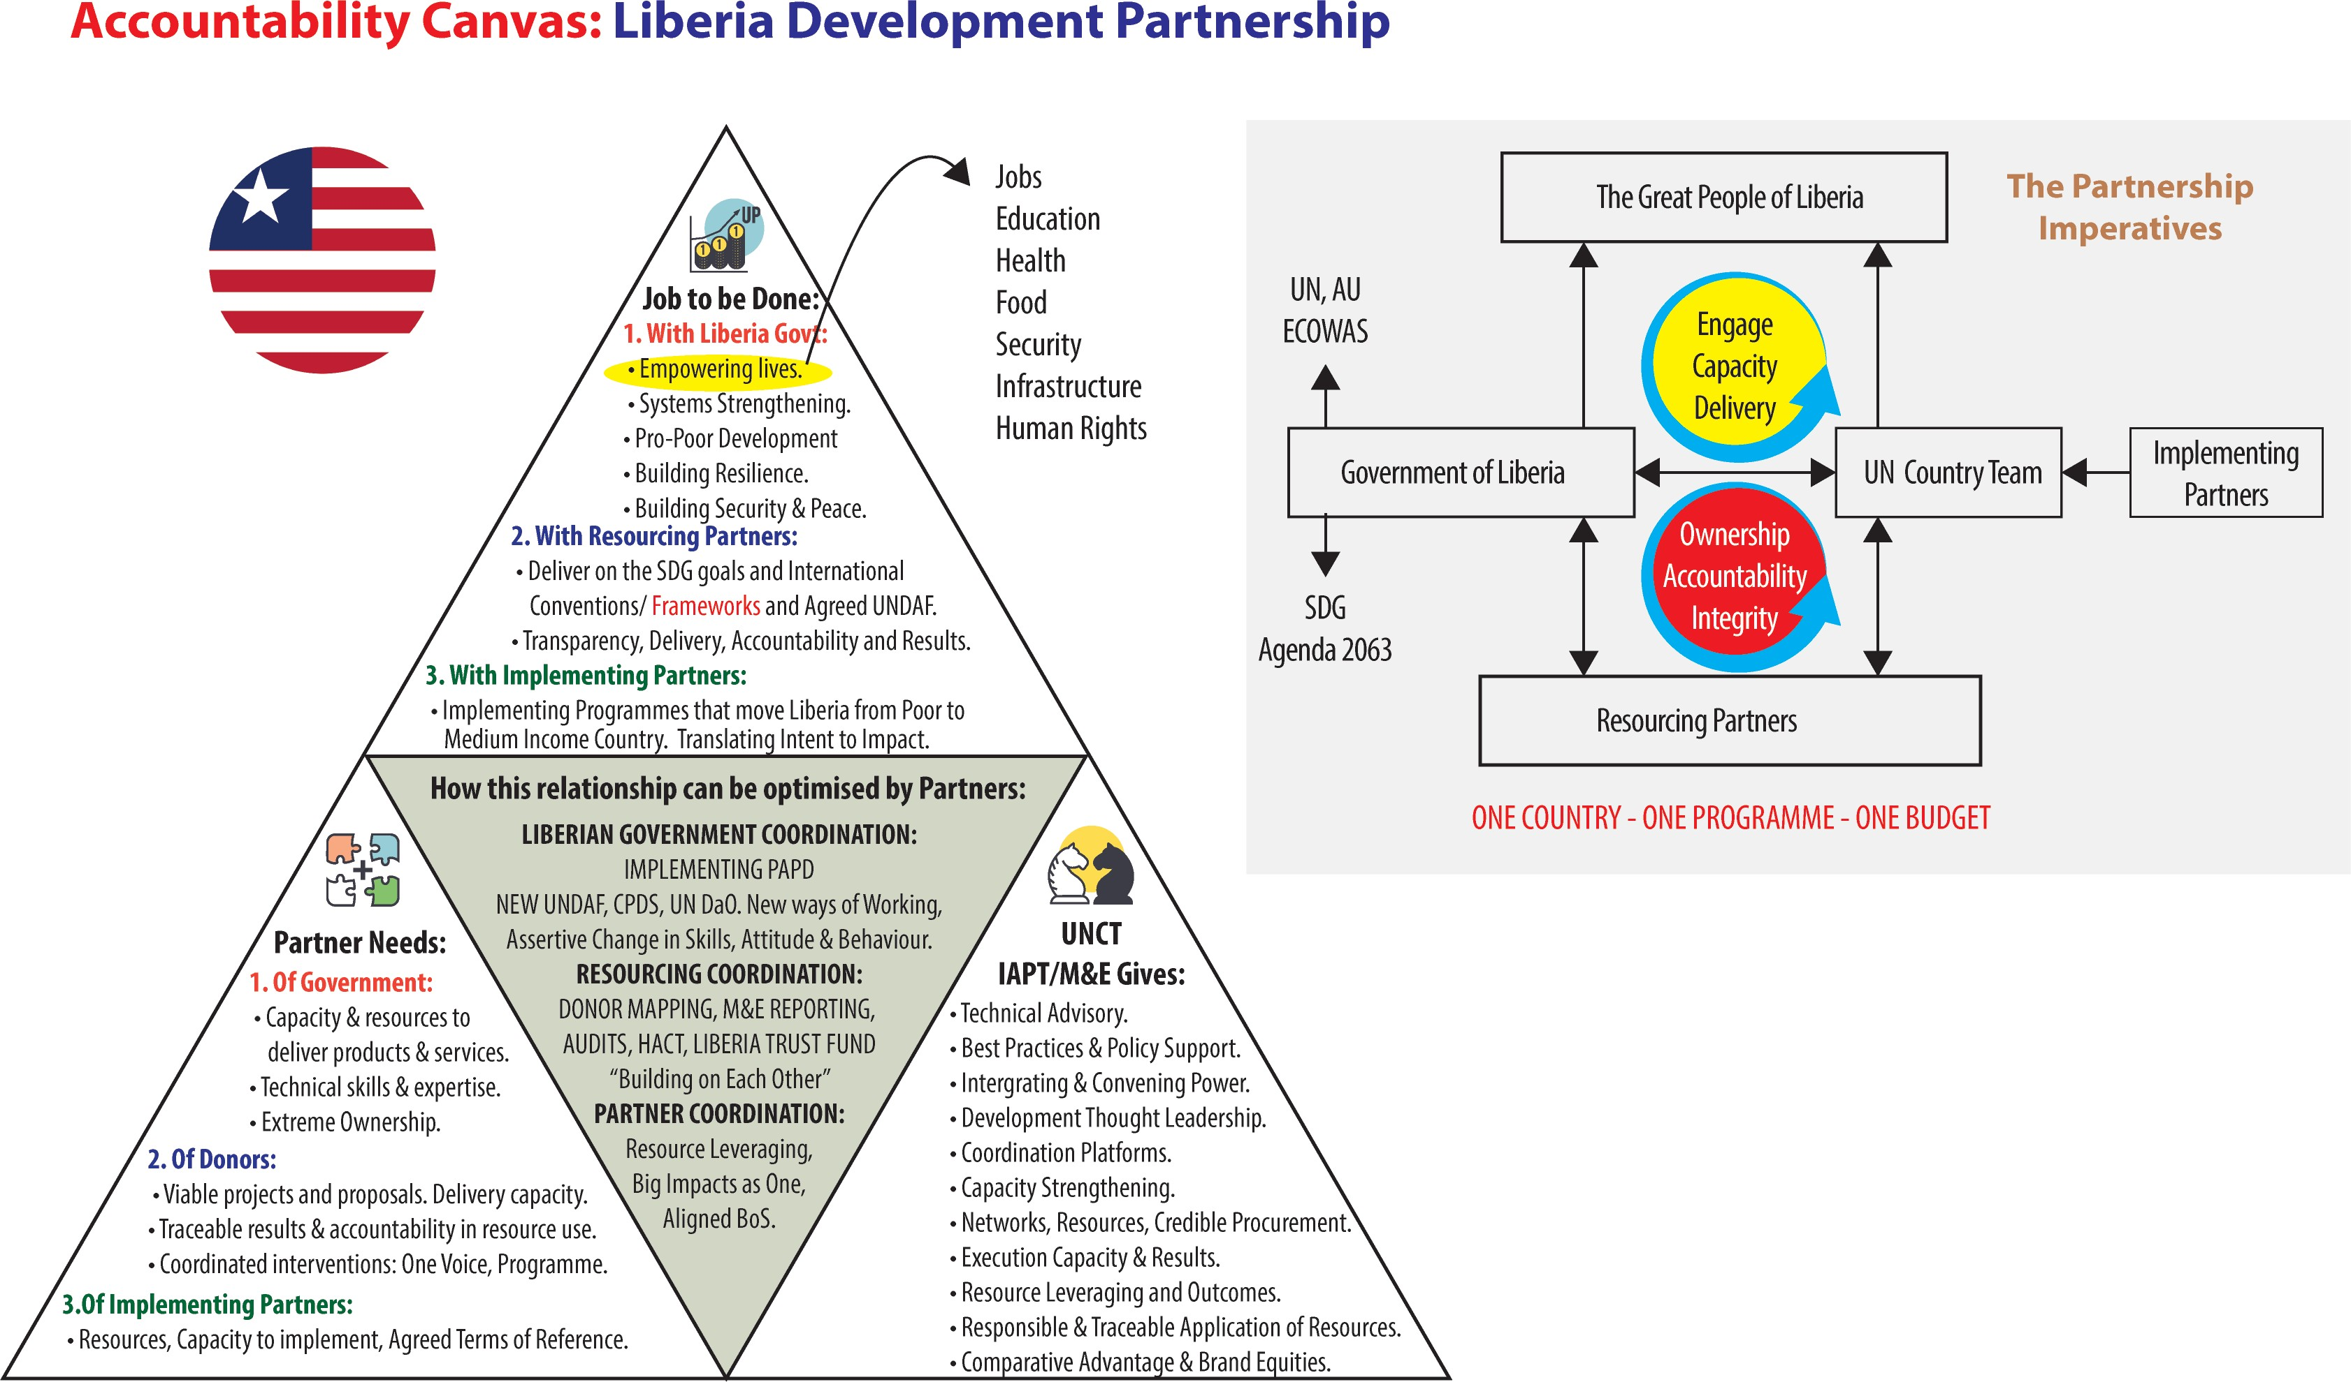

UN Comparative Advantage: A critical step in defining the comparative advantage for the UNCT in Liberia is the analysis of the development challenges that militate against the country’s development challenges to include: high level of youth unemployment; lack of youth skills and competencies, persistent negative impact of war tone atrocities; severe capacity gaps in the rule of law institutions; high vulnerabilities associated with ethnic, religious, gender based, class based polarization; an economy heavily dependent on imports, extractive industry and increasing debt
Against this background UN comparative advantages include: core approach of institutions development, capacity building and community engagement. Due to its global knowledge and rich technical support network, the UN can provide a leading role in driving the SDG agenda, mainstreaming SDGs in various sectors and monitoring performance around their targets. UN has comparative advantage on issues of SGBV, weak governance across sectors, human rights issues, access to education and health including issues of HIV and AIDS and national capacity development through volunteer schemes (volunteer infrastructure). The UN are particularly well placed to strengthen the rule of law and restore justice, security and protection services. The UN is trusted and reliable peace broker and can give credible support to governance challenges including consolidation of sustainable peace especially at grassroots levels, consolidate outstanding constitutional review processes. However, in order to make this possible and vibrant the UN needs to address internal weaknesses that have to do with issues of individual UN mandates, modalities of resource mobilization, reporting and accountability systems and HQ demands that are agency based which create competition among UN agencies and the demand for individual agency visibility instead of fostering Delivering as One.
Partnerships
Achieving the ambitious agenda for the 2030 SDGs calls for stronger partnerships in Liberia and a paradigm shift in stakeholder relationships. In light of the above, this CCA suggests a One Common Programme, One Fund (Trust Fund) and Jointly Owned Results. Strengthening stakeholder groups for effective contribution to national development priorities via the One Programme is paramount. Against this backdrop, the role of the UN in strengthening stakeholder coordination is: improving aid effectiveness, supporting open budget initiatives, improving of fund tracking for the proposed One Programme, One Fund and Jointly Owned Results. The role of the UN also includes support to the functioning of the LDA, needs assessment and development of the successor Macro-Economic Blue Print. The support to the SDG agenda (consolidating prioritization, mainstreaming and monitoring) is key. This however, cannot be done just from the country office perspectives or level, it will require the full support of the UN agency HQs that will enable and support in spirit, financially and administratively the Delivering as One Modality. In the absence of HQs support nothing will change as the evaluation has shown this is where the larger limitations lie.

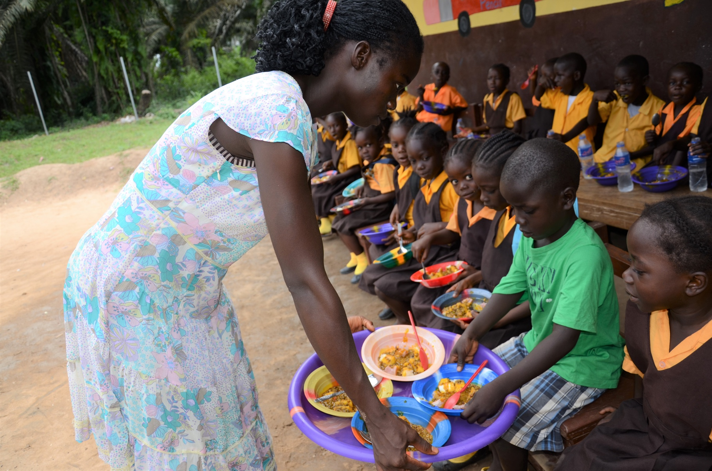

- UNSDCF 2020-2024 STRATEGIC PRIORITY AREAS

In response to Liberia ’s transformative agenda and development priorities, the Government and the UN agreed on four strategic results areas that will guide the work and collaboration between the Government of Liberia and the UN. These are:
- Basic Social Services: Improved rights-based, gender sensitive quality life with inclusive, equitable access and utilization of essential social services;

- Sustainable Economic Development: Diversified and inclusive economic growth; sustainable agriculture, food
- security, job creation; and resilience to climate change and natural disasters;
- Sustaining Peace and Security: Consolidated and sustainable peace; enhanced social cohesion, rule of law and human rights.
- Governance and Transparency: Good governance; transparent and strengthened institutions to the delivery essential services targeting the most marginalized vulnerable.

Figure 3: The UNSDCF 2020-2024
Output 2.4: By 2024, public and private sector players have strengthened capacity to increase economic participation and productivity , and in an inclusive manner enable employment, job creation and enterprise development.

Output 1.4: Timely collection, storage and analyses and access by users of complete statistics, appropriately disaggregated to inform equity-focused programmes, projects, planning, and evidence-based monitoring, evaluation and learning

Output 2.3: By 2024, access, awareness and sustainable use of appropriate Resources, Assets, Services and Markets by poor and rural producers, households, value-chain actors, and communities, including women and youth improved.

Output 3.3: Public trust and confidence in justice, security ad rule of law institutions enhanced at national and subnational level Suggested additional.

Output 2.2: By 2024, national and subnational capacity to deliver sustainable natural resource management and climate-aware initiatives is strengthened

Output 3.2: Capacities of national and sub-national actors strengthened to develop, amend and implement legislation and policies in compliance with human rights standards

Output 1.1: Institutions are strengthened to develop and implement policies, law, strategies that promote human rights and equitable social services norms

Output 2.1: By 2024, evidence based and cross­ sector gender responsive policy frameworks and accountability mechanisms that promote sustainable livelihoods, food security, social protection and resilience to climate change and other disasters are strengthened.

Output 3. 1: Enhanced Citizen Participation and Strengthened in Peace-building, reconciliation and inclusive mechanisms to pre-empt and address conflict and its causes, sustain peace and enhance social cohesion

By 2024, the most vulnerable and excluded groups have improved quality of life with rights-based, gender sensitive, inclusive, equitable access and utilization of essential social services in an environment free of discrimination and violence including in humanitarian situations.
By 2024, Liberia has diversified, and inclusive economic growth underpinned by investments in sustainable and environmentally friendly agriculture, food security, job creation and improved resilience to climate change and natural disasters.
By 2024, people in Liberia especially the vulnerable and disadvantaged, benefit from strengthened institutions that are more effective, accountable, transparent, inclusive and gender responsive in the delivery of essential services at the national and sub-national levels.
Power to the People
Governance and
Transparency

Sustaining the Peace
Economic and Jobs
By 2024, women, girls, men and boys in Liberia experience more sustained peace, inclusive and sustainable growth and development through strengthened formal and informal institutions providing access to effective and equitable justice and security services; promoting and protecting human rights; and strengthening social cohesion and reconciliation.
Output 4.4: Citizens' awareness on ethics, values, principles, integrity and professionalism for national develop and national and subnational level s increased

Output 4.1: Capacity of national and subnational institutions to formulate inclusive and responsive laws and policies for equal participation of men and women strengthened

Output 1.2: Capacity of national and sub national institutions to provide quality, equitable, inclusive and decentralized social services is enhanced.

Output 4.2: Enhanced and strengthened capacity of the national and sub-national institutions to provide quality,
gender responsive, equitable, client-focused and decentralized social and essential services.

Output 1.3: Improved awareness and access by the community leaders and members, including vulnerable and marginalized group-members, to quality, equitable, decentralized, and age and gender responsive social services.

Output 4.3:1ntegrity institutions are strengthened at national and subnational levels to advocate and assertively implement policies, legal and institutional frameworks and practices that promote transparency, accountability and rule of law.

Output 3.5. Relevant government authorities and security and justice institutions at national and subnational levels have better knowledge and capacity to enhance access to justice, including vulnerable groups, women and girl survivors of SGBV, and especially those facing multiple and intersecting forms of discrimination

Output 4.5: Capacities of institutions to conduct of free, fair and transparent election Strengthened

The overarching UNSDCF Theory of Change
More than 15 years after the civil in Liberia, the country remains fragile, faced with major challenges. Among these include the need to consolidate and sustain peace in the Country. Sustaining peace in Liberia would require taking into consideration the potential conflict risk factors which include:
1. Inadequate post-war reconciliation, constrained governance systems, perceived limited capacity of the government to safeguard peace, and limited social cohesion (CCA 2018).
2. Opportunities to benefit from sustainable economic transformation are an evenly distributed, coupled with unstable economic conditions which has limited the transformation of the public and private enterprise development, investment and inclusive economic growth. Moreover, space for the private sector to become vibrant and to deploy its resources and capabilities to support the delivery social services within the framework of a public private partnerships is enormous. The high levels of informal economic sector will need to be transformed to provide sustainable opportunities for the people of Liberia and unemployment be addressed alongside economic decentralization of public services which would ensure that the vulnerable and marginalized members of the community have equal access and utilization of these essential and basic services.
Gender inequality still remains the major drivers of inequality and exclusion, in Liberia, leading to large proportions of populations being left behind. Women and girls in Liberia are particularly disproportionately excluded from the public service and decision making, security and political arenas which limit equitable distribution, access and utilization of essential services.
Competencies for the respective government institutions and the public sector personnel to discharge duties efficiently, in an accountable and transparent manner; while taking responsibility and commitment for the duty-bear role and mandate in resources allocation and legislation on policies, budgets and strategic plans for results delivery have remained weak. Ministries, Agencies and Commissions (MCAs), working with partners, in Liberia will require strengthening to deliver equitable, inclusive, quality and gender and age-sensitive integrated quality social services and both national and community level.
The general legal and regulatory framework for good and accountable taking account of values, ethics, norms at national and sub-national and levels to inform decisions, and development outcomes and interventions and environment that is free from all forms of harmful practices, discrimination and violence, especially on women and girls will require strengthening.
Liberians in particular, the vulnerable and marginalized remain fragile to the impacts of climate change, environmental and natural disasters.
The United Nation System in Liberia is committed to support country become a reconciled, transformed and prosperous nation anchored on accountable institutions and equitable, inclusive and sustainable development. Through this sustainable development cooperation framework, United Nation, informed by its comparative advantage, will focus on four broad strategic priorities namely:
- Human Develop and Essential Social Services: Support improved rights-based, gender sensitive quality life with inclusive, equitable access and utilization of essential social services- aligned to PAPD Power to the People Pillar;
- Sustainable Economic Development: Support diversified and inclusive economic growth; sustainable agriculture, food security, job creation; and resilience to climate change and natural disasters;
- Sustaining Peace, Security and Rule of Law: support the Government of Liberia consolidate and sustain peace; enhance social cohesion, rule of law and human right
- Governance and Transparency: support good governance; transparency and strengthened institutions to the delivery essential services targeting the most marginalized vulnerable
These four strategic priorities, the United Nations, in partnership with other development partners envisages change and progress in Liberia resulting to a peaceful, healthy, empowered and productive nation such that, the People in Liberia, including women, children, youth, marginalized and vulnerable will be able to access and utilize quality social services in an effective and equitable manner to better their lives and well-being; All People in Liberia, irrespective of their status will have the opportunity to contribute to, participate in, and benefit from shared and inclusive economic growth, sustainable environment and are able to build resilience against vulnerabilities, shocks and disasters; that Women, Men Girls and Boys will enjoy sustained peace & security, enhanced reconciliation, minimized fragility, reduced violent tendencies, and equal access to justice and rule of law services; that the vulnerable groups will demand and benefit equitably from accountable and transparent delivery of essential public services (at national and sub-national levels) with their views and perspectives solicited, respected and fulfilled;
The United Nations is cognizant of the challenging and fragile environment and thus seeks to support the government with the assumption that:
1. The capacity strengthening will lead to delivery of social services in decentralized, equitable manner, in line with the law, policies, standards, norms, frameworks ensuring that the rights holders have the knowledge, service seeking behaviors and capacity to utilize them. Economic transformation, value chain developments, enterprise creation and diversification result in shared prosperity in an environmentally sustainable way. Critical structural constraints that impede the access of women and men to employment, livelihoods and income security are addressed in a sustainable manner; and
2. The formal and informal peace, justice, security, and human rights institutions, along with communities, will have identified and mitigated the root causes of conflict in a mutually accountable inclusive and participatory manner and they all strive for positive peace; Policy, legal and institutional frameworks are strengthened, and communities are engaged to promote accountability and transparency in the delivery of gen- der responsive public services at the national and sub-national levels.
.

2.1. Principles and approaches for integrated Programming

The UNSDCF is informed by the global programming principles and approaches: Leave No One Behind; human rights, gender equality and women’s empowerment; sustainability and resilience; and accountability towards realization of SDGs. The principle of Leaving No One Behind is embedded in the links between rights-holders and duty bearers presented in each of the outcome statements. This UNSDCF will foster social inclusion to address inequality and socio-cultural discrimination, which are perceived as some of the root causes of exclusion, vulnerability and conflict in the country. These principles and approaches will be applied at all phases of programme design, implementation, and management including monitoring and evaluation. Data generation and adaptability to changing circumstances will be cross-cutting strategies. This UNSDCF includes specific results on human rights, gender equality and environmental protection under the relevant outcomes, as well as mainstreaming the three normative principles across entire UNSDCF.
The UN will address youth as a specific priority group by mainstreaming youth perspectives and relevant action across all UNSDCF outcome areas. The UN will promote an enabling environment that recognizes the rights of youth and enhance meaningful engagement of youth as essential actors in civic and political decision-making processes at all levels. In addition, focus will be placed on ensuring availability of age and sex disaggregated data in support of an analysis of the needs and priorities of young men and women, including youth among vulnerable and marginalized groups. Each outcome has specific strategies, partners, and vulnerable groups including the youth to benefit from the programme results.
This UNSDCF, through field presence, will seek to support the integrated area based and flagship programmes through UN joint integrated approaches among others at the counties ensuring that the UN reaches the furthest and the marginalized communities thus ensuring inclusion and equity to reach the most disadvantaged – ‘leave no one behind’ (LNOB). To address the very high levels of inequality in Liberia especially the counties that resulted in marginalization in the access to social services, the UNSDCF adopt a human rights-based and gender equality approach, reaching the marginalized counties first and deepening development interventions and addressing inequity and marginalization. The principle of leave no one behind (LNOB) will be mainstreamed throughout the UNSDCF through:
- Evidence based planning and implementation: Generation and analysis of evidence based disaggregated data to inform development programming and initiative;
- Ensuing Inclusiveness: The targeted group’s needs, rights and priorities will be considered, and their participation ensured during all programming phases;
- People Centered Approaches and initiatives that will ensure that the programming results benefit the target groups directly.
- Capacity Strengthening: Deliberate strengthening Civil Society Organization and communities in applying the LNOB principle will be done to ensure equitable social development focusing on the marginalized and vulnerable groups including: Women, Youth, Children (children under 5 years of age; children with disabilities, out of school children, particularly girls and children living in marginalized in the most neglected communities and urban informal settlements), Pregnant and lactating women, Persons with disabilities, Key populations at higher risk of HIV infection: men who have sex with men, female sex workers, injecting drug users, Refugees, Populations living in urban informal settlements, Rural communities that lack access to basic services such as health, education, nutrition and social protection services.
To ensure equitable and sustainable growth focus will be on:
  - Households living at or near poverty; Children from low income households.
      - Working women and female headed households.
      - Young people (15-24), unemployed or not in education, especially in informal settlement and in rural areas and communities.
      - Persons with disabilities
      - Women (and men) survivors of gender-based violence,
      - Rural smallholders living in or near poverty and communities affected by climate change and environmental degradation.

Human rights-based approach:
The UNSDCF will adopt a human rights-based approach (HRBA) in programming to support sustainable development outcomes and also continuously analyze and address inequalities and discriminatory practices in programming. Liberia is signatory to all main UN human rights treaties that provide for economic, social and cultural rights, civil liberties and fundamental freedoms. While the legislative and institutional framework for the observance of international human rights law is mostly in place, implementation is under-funded and inconsistent. Further efforts are needed to ensure full implementation of the legal framework and international instruments. Across all priorities, the UN will give support to further develop and strengthen capacities to implement the recommendations of both UN human rights mechanisms as well as recommendations from independent state oversight bodies. The UN will also support Government and civil society reporting and engagement with UN treaty body reviews and the Universal Periodic Review (UPR). The UN will ensure human rights is mainstreamed during programming.

Gender Equality and Women’s Empowerment
Liberia is a signatory to CEDAW - a binding international treaty that guarantees the equality of men and women and prohibits gender-based discrimination. The UN will support Liberia address issues raised in the CEDAW review of Liberia; which recommended actions towards advancing women’s rights.
In supporting the Government’s gender equality efforts, the UNPF 2020-2014 will apply multi-faceted approach that promote both the mainstreaming of gender in all UNPF outcomes areas as well as developing targeted initiatives to address specific gender results that call for a multi-faceted response by multiple actors. UNPF will support the Government’s flagships on women’s economic empowerment, advancing women’s participation in public leadership, ending harmful practices and Gender Based Violence (GBV).
Sustainability and resilience
UNPF -2020-2024 puts sustainability at the heart of all its planned results and activities to ensure a successful implementation of the 2030 Agenda of increasing the resilience of communities’ governance and ecosystems, strengthen institutional capacities to enhance human well-being, and reduce risks and vulnerabilities associated with natural hazards and disasters in Liberia. It will also make it possible to ensure implementation of internationally agreed policy frameworks or conventions ratified by Liberia including the Paris Agreement, the Addis Ababa Action Agenda and the Sendai Framework for Disaster Risk Reduction, among others. The use of the principle will inform the policy process through the UN technical support and analysis at both, the macro-economic, sectoral and county levels.
This principle will support the application of overarching principle of leaving no one behind which recognizes the need for protecting ecosystems and biodiversity; targeting the poor as they provide the bases for livelihoods and employment for many of the poor. These will involve measures to:
- Raise awareness of environmental challenges and shaping the attitudes and behaviors that can make a difference through education.
- Strengthen implementation of environment policies and strengthen the nature conservation and sustainable use of natural resources.
- Strengthen formulation of local action plans to address ecosystem and land degradation, deforestation, and help communities to withstand shocks and manage risks and uncertainties.
- Create national, regional and international market access opportunities for products from women and youth-led micro, small and medium enterprises (MSMEs) in the informal sector;
- Encourage equal participation of women in natural resource management
The UNPF will address sustainable development in a crosscutting manner given its paramount importance to support the 5 Ps of the SDGs (People, Planet, Prosperity, Peace, and Partnership), and with emphasis on Peace and Partnerships. “Peace”- that is very pertinent for Liberia.
Accountability:
The UNDAF will strengthen national and local mechanisms, institutions and processes to ensure availability of quality disaggregated data to monitor and report on the progress of implementation of SDGs and Agenda 2063.
Results-focused programming Results groups (the Pillars and sector groups) will support implementation, management, monitoring, and reporting of progress towards the planned UNDSCF outcomes. Indicators for the outcomes listed in the Results Framework and the outputs to be formulated as part of work plans will be reviewed and aligned, as appropriate, with PADP and SDGs indicators framework.
Development, humanitarian and peace-building linkages:
The UNDAF builds on growing recognition that humanitarian, development, and peace-building efforts are complementary and need to reinforce each other to respond to Liberia ’s vulnerability to inter and intra communal conflicts, violent tendencies, natural disasters and climate change. The UN will prioritize prevention and mitigation of shocks caused by various factors including conflict and natural disasters or epidemics by supporting the Government and other national partners to address the root causes and reduce risk of conflicts and disasters. The prevention agenda will be integrated into development policies and efforts to save lives, and safeguards development gains ensuring that communities are resilient.
Capacity development:
To ensure that development efforts are nationally owned, sustainable and achieve the goals of Agenda 2030 and Agenda 2063, a capacity development approach will inform all aspects of this UNPF based on sound capacity assessments and innovative measures to address institutional bottlenecks. The Government and the UN will continue to promote stronger, deeper engagement with civil society groups and to sustain their support and services for marginalized vulnerable groups. On agriculture and resilience building, interventions to strengthen the capacity of partners to implement the Malabo Declaration on Accelerated Agricultural Growth and Transformation for Shared Prosperity and Improved Livelihoods adopted by the African Union Heads of State and Government in June 2014 will be of critical emphasis. The declaration was a recommitment to the principles and values of the Comprehensive African Agriculture Development Programme (CAADP) which include the pursuit of agriculture-led growth as a main strategy to achieve targets on food and nutrition security and shared prosperity.
Risk-informed programming: The UN will consider economic, social, and environmental ‘risks to’ programming as well as ‘risks from’ programming. Risk-informed development programming will not only entail managing disaster risks and climate impacts, but also seek to protect development gains. Considering the Liberia ’s significant threats shocks and fragility. The UN will ensure that its interventions are in line with “do-no harm” principle, are conflict-sensitive and avoid negative impacts and maximize positive impacts toward promoting peace and stability.
Partnerships: The UN will convene, facilitate, and leverage strategic engagement with various partners’ drawn from both the state and non-state actors at national and county levels to ensure national ownership and accountability. This will build on and scale up existing partnership platforms of Public-Private Partnership (PPP) initiatives in Liberia. South to South and Cooperation and fostering of greater ties with civil society and the private sector will be further promoted alongside fostering for a more sustainable form of development.

2.2. Expected Results for Pillar 1

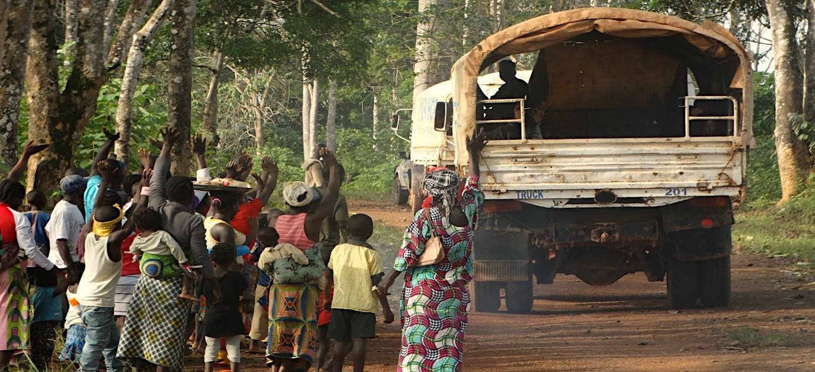

STRATEGIC PRIORITY I: POWER TO THE PEOPLE

Strategic Priority 1 of the LUNPF focus on improving the “human Capital and the rights-based, gender sensitive quality life with inclusive, equitable access and utilization of essential social services” in Liberia. This priority has one outcome and four outputs as outlined below:

Figure X: Strategic Priority 1: Human Development and Essential Social Services
Pillar One: Power to the People
1.1: Institutions are strengthened to develop and implement policies, law, strategies that promote human rights and equitable social services norms

Related SDG (s): Goal 1: No poverty; Goal 2: Zero hunger; Goal 3: Good health & well-being; Goal 4: Quality education; Goal 5: Gender equality; Goal 8: Decent work & economic growth; Goal 10: Reduced inequalities; Goal 17: Partnerships for the goals
1.2: Capacity of national and sub national institutions to provide quality, equitable, inclusive and decentralized social services is enhanced.

PAPD Pillar One Outcomes:
- Achieving a more inclusive and higher quality formal education, TVET, and adult learning with greater access to ICT;
- Increased access to quality essential health and reduced overall morbidity/mortality with special focus on HIV/AIDS, TB, malaria, and major RMNCAH outcomes
- Increased and improved access to integrated services for Youths and Young Adults
- Gender equality entrenched as a cross-cutting issue leading to more empowered women and girls and clearer understanding among men and boys to act as champions
- Expansion to the social safety net through social assistance, scaled-up cash transfer, and inclusion through work opportunities for the most vulnerable and extremely poor groups and regions

Output
Alignment to SDGs
Strategies
STRATEGIC PRIORITY 1: By 2024, the most vulnerable and excluded groups have improved quality of life with rights-based, gender sensitive, inclusive, equitable access and utilization of essential social services in an environment free of discrimination and violence including in humanitarian situations.

1.3: Improved awareness and access by the community leaders and members, including vulnerable and marginalized group-members, to quality, equitable, decentralized, and age and gender responsive social services.

1.4: Timely collection, storage and analyses and access by users of complete statistics, appropriately disaggregated to inform equity-focused programmes, projects, planning, and evidence-based monitoring, evaluation and learning

The actions to achieve the results outlined above will support the Government to realize the national priorities towards attainment of PADP targets and respective SDGs with focus on:
- Strengthening the capacities of government institutions, both at national and subnational level to develop and implement policies, law, strategies that promote human rights and equitable social services and norms.
- Enhancing the capacities of national and sub national institutions to provide quality, equitable, inclusive and decentralized social services.
- Improving awareness and access by the community leaders and members, including vulnerable and marginalized group-members, to quality, equitable, decentralized, and age and gender responsive social services.
- Strengthening the capacity of national and subnational institutions capacity for timely collection, storage and analyses and access by users of complete reliable statistics, appropriately disaggregated to inform equity-focused programmes, projects, planning, and evidence-based monitoring, evaluation and learning
The Theory of Change underlying Strategic Priority One is premised on the principle that the Government and its institutions have the full responsibility and accountability and if they carry out their mandate, allocating resources for formulation of policies, budgets and strategic plans for results delivery; and that relevant ministries, Agencies & Commissions, have the capacity to work with the partners, to deliver equitable, inclusive, quality and gender and age-sensitive integrated social services; ensuring the participation of women in decision making is encouraged and enabled to promote equitable distribution, access and utilization of essential services; that if the environment in all communities is free of all forms of harmful practices, discrimination and violence and people feel safe, exercise responsibility and enjoy their rights; that the people, community level institutions and leadership complement all levels of government in raising awareness, provision and utilization of quality social services; if the private sector deploys its resources and capabilities to support the delivery social services within the framework of Public Private Partnerships; and access and utilization of social services, is based on credible and evidence-based data generated, disaggregated, stored, processed and disseminated and used; Then people in Liberia, including women, children, youth, marginalized and vulnerable will be able to access and utilize quality social services in an effective and equitable manner to better their lives and well-being;
Based on this , the UN in Liberia will support the government in availing social services, especially at the decentralized level, in line with law, policies, standards and frameworks; inclusive for all women, children, youth including adolescents/young people and other vulnerable groups; and to ensure these rights holders have the knowledge, service seeking behavior and capacity utilizing it.

Rationale:

The essential social services environment in Liberia is characterized by myriad of challenges including:
- Limited access to Social Services,
- Limited knowledge, capacity, commitment and sense of the duty bearers, accountability to deliver Social Services;
- limited knowledge, power and means by Right holders about and to demand their rights to Social Services.
- Services and systems are highly centralized thus limited access to equitable basic social services especially in remote areas.
- Where systems exist, the environment is characterized with weak coordination and implementation of existing policies and strategies including low capacity to supervise and monitor the policy and strategy implementation.
- Limited generation and utilization of data/information. Poor quality of data not appropriately disaggregated, and frequency of collection is irregular,
- Limited financial resources and constrained fiscal space, and challenges with financial inclusion.

Strategic Priority One (1) is very critical as it lays the foundation for sustaining any investment in related to development sector. The Government, in the Medium-Term Plan (PAPD 2018-2023) prioritizes i) human capital development as cross-cutting foundation for the various social sectors ii) reducing out of school rates and increasing retention and completion rates for girls and boys; iii) ensuring appropriate responses to Gender-Based Violence, are major thrusts under human capacity development; iv) reducing the maternal mortality rate in under-five malnutrition of girls and boys; v) malnutrition prevention and vi) reducing women inequality in political, social, and economic life. Based on these Government priorities, Strategic Priority One has been designed along these priorities in integrated manner.

Strategies:
Based on the Human Development and Social Services priority, the UN in Liberia will provide support that builds on its relative strengths and comparative advantage including:
  - Identifying, involving and protecting vulnerable groups and upholding human rights including in the counties. Ensure ‘Leave No One Behind’ principle is central by promoting an inclusive service delivery approach that targeting the most disadvantaged and marginalized women, girls, men and boys, including people living with disabilities;
  - Forge meaningful, sustainable and diverse partnerships and collaborations that cut across government line ministries, development partners, CSOs, traditional and non-formal institutions and the private sector from programme planning to implementation, monitoring and reporting. Ensure use of participatory and inclusive approaches, that take account of complexity and multi-sectoral nature of delivery of essential social services. Ensuring increased buy-in, ownership and involvement amongst the various stakeholders.
  - Ensure decentralized delivery and demand creation at the county, district and community level accelerated services to ensure reach of ‘the furthest first’ addressing the challenges of access, timely and quality rights holders-centered and sensitive assistance.
  - Create greater ownership, commitment leading to action and accountability of the Government to deliver essential social services. This is particularly important in Liberia due to the diminishing fiscal space and over reliance of foreign aid development financing.
  - Sustain efforts towards building and strengthening institutional capacities of relevant government line ministries with the core mandate of delivering essential social services. Ensure link with efforts to continue strengthening the relevant sectors (Health, Education, Social Protection/child protection, Gender, and Youth sector) and its systems. Support will include advocacy for better plans, budget and increased budgetary allocation including on gender responsive budgeting.
  - Strengthen capacities of traditional, religious leaders and non-formal institutions on gender equity through awareness raising, reinforcement of positive cultural norms and behavior change initiatives;
  - Strengthen rights based, gender-sensitive social service delivery through aligning social sector policies, plans, programmes with relevant human rights standards. This will include strengthening comprehensive prevention approach aimed at eliminating Sexual Gender Based Violence (SGBV) and Harmful Practices (HPs), particularly at the community level, working with traditional, religious leaders and male groups; aligning better data collection efforts on prevention; and strengthening partnerships with civil society and women’s movements/organizations;
  - Ensure effective translation of human rights commitments in social service sector through budgetary allocation, systems strengthening, human capital recruitment and effective services delivery including in costing of sectors/MACs Strategic Plans for resource mobilization.
  - Ensure evidence-based planning through identifying data-needs, collection and analysis to ensure no one is left behind and support knowledge management to further enhance accountability;
  - Address harmful social norms and values that impede accessing certain services. Appreciate and support the positive cultural heritage, values, rituals and teachings must to increase awareness and demand on other services;
    - Deliver as “One UN” in a coherent, coordinated and concerted manner during programme planning, implementation, reporting, monitoring and evaluation, in both inter-ministerial and ministerial support to key line ministries, CSOs, non-state institutions and the private sector. Central to this coordination will be jointly identifying developing and implementing joint, integrated area-based flagship programmes that are impactful, effective cost efficient at the county level. To the extent possible, the co-located UN offices will be established in the counties to increase efficiency of support to the government and delivery of essential services
and most importantly reach the targeted vulnerable populations.

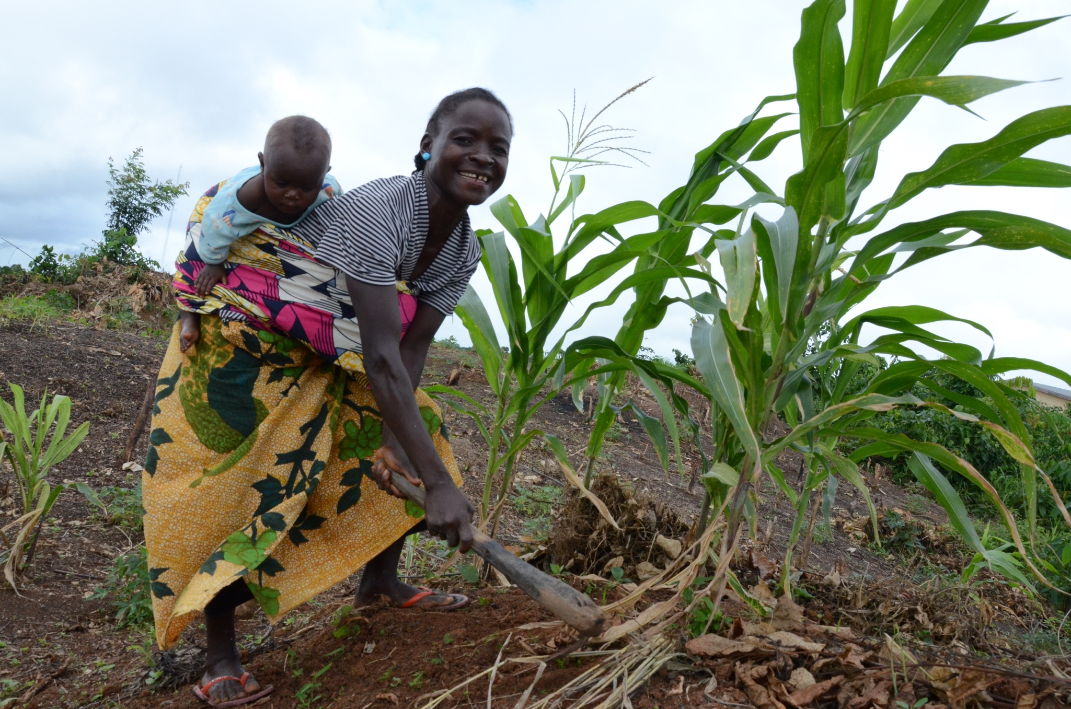

STRATEGIC PRIORITY I: POWER TO THE PEOPLE

STRATEGIC PRIORITY II: ECONOMY & JOBS

This Strategic priority 2 focuses on supporting the Government to have a “Diversified and inclusive economic growth underpinned by investments in sustainable and environmentally friendly agriculture, food security, job-creation and improved resilience to climate change and natural disasters”. This entails supporting the Government in “… maintaining macroeconomic stability, building good infrastructure, and providing a business-friendly environment that can stimulate private productive investments and create more and better-quality jobs that are germane to sustaining the peace and to future economic growth…” The actions under this priority will support the Government accelerate economic growth targets in the PAPD 2018-2023. The national priorities include:
- Creating the right policy environment focusing on expanding fiscal space, stabilizing the monetary systems and enhancing fiscal inclusion, and transforming the business regulatory environment and investment climate.
- Increasing the competitiveness of existing industries focusing in increasing agricultural production and productivity, and natural resource management.
- Transforming infrastructure with emphasis on roads, air and sea transport, access to affordable energy, and water and sanitation.
- Sustaining medium to long-term economic growth targeting improvement in governance and management of State-owned Enterprises, diversifying the economy through private sector engagement and expanding regional integration.

Pillar Two: Economy and Jobs
STRATEGIC PRIORITY 2:( PILLAR 2By 2024, Liberia has diversified, and inclusive economic growth underpinned by investments in sustainable and environmentally friendly agriculture, food security, job creation and improved resilience to climate change and natural disasters.

Output
Alignment to SDGs
Strategies

- An improved and inclusive policy environment for private sector-led economic growth and balanced revenue and expenditure outturns
- Increased equitable agricultural production and productivity and improved forest utilization through competitive value chains and market linkages for food and income security, economic growth, and job creation
- Increased social and economic activity and connectivity through critical infrastructure improvements that is also inclusive
Improved fiscal and monetary policy management to sustain economic growth and job creation
RELATED SDG (s)
Goal 2: Zero hunger, Goal 5: Gender equality, Goal 6: Clean water and sanitation, Goal 7: Affordable and clean energy, Goal 8: Decent work and economic growth, Goal 9: Industry, innovation and infrastructure, Goal 10: Reduced inequalities, Goal 11: Sustainable cities and communities, Goal 12: Responsible consumption and production, Goal 13: Climate action, Goal 15: Life on land
Goal 17: Partnerships for the Goals
2.1: By 2024, evidence based and cross­ sector gender responsive policy frameworks and accountability mechanisms that promote sustainable livelihoods, food security, social protection and resilience to climate change and other disasters are strengthened.

2.2: By 2024, national and subnational capacity to deliver sustainable natural resource management and climate-aware initiatives is strengthened

2.3: By 2024, access, awareness and sustainable use of appropriate Resources, Assets, Services and Markets by poor and rural producers, households, value-chain actors, and communities

2.4: By 2024, public and private sector players have strengthened capacity to increase economic participation and productivity, and in an inclusive manner enable employment, job creation and enterprise development.

In support of the above government priorities, under Strategic Priority 2: and based on the comparative advantage of Agencies, the UN will focus on the following areas

- Strengthen evidence based and cross-sector gender responsive policy frameworks and accountability mechanisms that promote sustainable livelihoods, food security, social protection and resilience to climate change and other disasters;
- Strengthen national and sub-national capacity to deliver sustainable natural resource management and climate-aware initiatives;
- Improve access, awareness and sustainable use of appropriate Resources, Assets, Services and Markets by poor and rural producers, households, value-chain actors, and communities, including women and youth;
- Strengthen public and private sector players’ capacity to increase economic participation and productivity, and in an inclusive manner enable employment, job creation and enterprise development at national and sub- national levels.

Rationale

Before 2014, the t the economy had grown by 8.4 percent and 8.8 percent in 2013 and 2014 respectively, before suffering two shocks- global commodity price reduction of the major extractive commodities and the EVD outbreak, In 2014, the growth rate declined to 0.7 % in 2015 and - 1.6% in 2016 before improving to 2.5% in 2017 and 3.2 % in 2018. In 2019, the economic indicators portrayed a declining economy including high inflation rate of 28% and a 24.5% depreciation of the Liberian dollar against the US dollar and an economy that relies heavily on export of primary extractive commodities whose market remain volatile.

The magnitude of the problem underscores the need for a focused approach to spur growth in the productive sectors, including agriculture, extractives, manufacturing, trade, and service industries, that have enormous potential to contribute to growth and employment creation; and, catalyze structural economic transformation.

The Theory of Change for economic transformation, enterprise creation and diversification is underpinned by the need to creating a conducive policy environment that provides opportunity for all to benefit equitably from sustainable economic transformation and for macro-economic stability; to trigger enterprise development, investment and economic growth thus creating a more productive employment with more women gaining access to productive employment, income security and improved livelihoods. As such all People in Liberia, irrespective of their status – will have the opportunity to contribute to, participate in, and benefit from shared and inclusive economic growth, sustainable environment and are able to build resilience against vulnerabilities, shocks and disasters;

Strategies:

The UN, building upon the best practices and lessons learned, will support the PAPD priorities through the following strategies:
- Productivity: Work towards raising the productivity and income of every Liberian worker by creating a conducive policy environment, enhancing competitiveness, and extending and upgrading the nation’s infrastructure.
- Collaboration: UN will apply an integrated innovative approach to programming and advocates for collaborative actions across sectors and involves all relevant stakeholders, ensuring that we leave no one behind, respect for human rights, gender equality and women’s economic empowerment; sustainability and resilience; and accountability grounded in the norms and standards of the UN to uphold and promote, and respond to national priorities and plans.

- Evidence-Based Action: Identify, support and advocate for effective evidence based public policies, and use of national institutions, systems and domestic resources as the primary means of raising the productivity and incomes of every Liberian, especially the excluded and marginalized, endeavoring to reach those who are furthest first.
- Ministries, Agencies and Commissions (Macs) Synergies: Promoting inter-ministerial coordination amongst MACs to better plan, budget and advocate for increased budgetary allocation, while ensuring that gender-responsive budgeting is carried out.
- Messaging: Ensure sustained engagement at the leadership level, common positioning and messaging on sensitive issues and regular dialogue at the working level through regular communication amongst and among partners and stakeholders at national and local levels.
- Causality: In undertaking analytical work, seek to identify the root causes of multidimensional poverty and building capacities for resilience recognizing that this provide the bases for livelihoods and employment for many of the poor and those left furthest behind.
- System Strengthening: Strengthen national systems and processes of accountability to monitor progress and performance to provide remedies which will ensure the effectiveness of institutions and mechanisms that monitor and track progress in empowering those who are left behind or at risk of falling behind.
- Data and Information Management: Support the generation of disaggregated data to inform programming and decision making.
- Scaling Up: Replicating, Upscaling successful and innovative models, working to apply best practices and build on existing experiences of the various Agencies and implementation experiences.

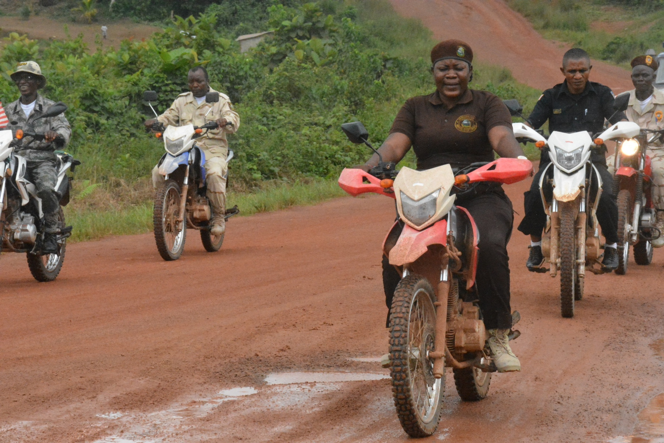

STRATEGIC PRIORITY III: SUSTAINING PEACE

UNSDCF 2020-2024 Strategic Priority 3 focuses on efforts that will sustain peace, promote inclusive and sustainable growth and development through strengthened formal and informal institutions that will provide access to effective and equitable justice and security services; promoting and protecting human rights; and strengthening social cohesion and reconciliation in Liberia. The actions under this priority will support the Government to promote a peaceful, unified society that enables economic transformation and sustainable development as stipulated in the PAPD 2018-2023. The national priorities include:

- Ending Fragility and the Root Causes of Conflict through promoting a cohesive society for sustainable development. This will lead to a society that embraces its triple heritage and guarantees space for all positive cultures to thrive;
- Ensuring Equal Justice and Human Rights by ensuring Justice Systems work to the benefit of the poor and most marginalized / National ownership and sustainability of access to justice and rule of law initiatives which will lead to a society where justice, rule of law and human rights prevail;
- Strengthening National Security and National Defense by ensuring security forces are more professional and inclusive and responsive to the needs of Liberian people. This will lead to an improved security service delivery nationwide and adequate capacity to deter and or respond to security threats.

Pillar Three: Sustaining the Peace
STRATEGIC PRIORITY THREE: By 2024, women, girls, men and boys in Liberia experience more sustained peace, inclusive and sustainable growth and development through strengthened formal and informal institutions providing access to effective and equitable justice and security services; promoting and protecting human rights; and strengthening social cohesion and reconciliation.

Output
RELATED SDG (s): SDGs
Goal 5: Gender equality and empower all women and girls
GOAL 16: Promote peaceful and inclusive society for sustainable development, provide access to justice for all and build accountable and inclusive institutions at all levels
Reconciliation:
- Liberia’s Social Cohesion and Reconciliation Index (SCORE) rating improves from 66% to 80%
- SCORE Index rating for civic trust and coexistence improves from 52% to 70% on (disaggregated by county, gender)
- SCORE Index rating for violent tendencies decreases from 19% to 5% on SCORE Index (disaggregated by county, gender)
Justice and Human Rights
- Share of people that are satisfied with the quality of judicial system or rule of law available to their household (% of people satisfied and very satisfied, disaggregated by county, gender) from 69.1% to 85%
- Increase adjudication of cases rate from 50% to 75% annually
- Proportion of BCR detainees held without trial decreases from 65% to 20%
- Juvenile Diversion Program available in 8 counties (baseline 5) 10% reduction in crimes
- By 2023, Liberia's compliance with International, Regional and National Human Rights Obligations and reporting on implementation is improved by 80%
Security and National Defense
- 10% reduction in violent crimes
Security and National Defense
Share of people that are satisfied with their protection against crime/their safety (% of people satisfied and very satisfied disaggregated by county, gender) from increases from 69.4% to 85%
Alignment to SDGs
Strategies
3.3: Public trust and confidence in justice, security ad rule of law institutions enhanced at national and subnational level Suggested additional.

3. 1: Enhanced Citizen Participation and Strengthened in Peace-building, reconciliation and inclusive mechanisms to pre-empt and address conflict and its causes, sustain peace and enhance social cohesion

3.2: Capacities of national and sub-national actors strengthened to develop, amend and implement legislation and policies in compliance with human
rights standards

3.5. Relevant government authorities and security and justice institutions at national and subnational levels have better knowledge and capacity to enhance access to justice, including vulnerable groups, women and girl survivors of SGBV, and especially those facing multiple and intersecting forms of discrimination

Under Strategic Priority 3, and in support of the aforementioned government priorities, and based on the comparative advantage of Agencies, the UN will focus on the following areas:
- Enhance citizen participation and strengthen the peace-building, reconciliation and inclusive mechanisms to pre-empt and address conflict and its causes, sustain peace and enhance social cohesion;
- Strengthen capacities of national and sub-national actors to develop, amend and implement legislation and policies in compliance with human rights standards;
- Enhance public trust and confidence in justice, security and rule of law institutions at national and subnational levels;
- Promote better knowledge and capacity of relevant government authorities and security and justice institutions at national and subnational levels to enhance access to justice, including for vulnerable groups, women and girl survivors of SGBV, and especially those facing multiple and intersecting forms of discrimination

Rationale
The Government has prioritized the need for sustainable peace as essential for all other investments to thrive. It cognized a peaceful and unified society as the bedrock on which human development, transformative economy and building a capable state that governs effectively and transparently are build.

Significant gains have been achieved since the cessation of civil war in 2003. The security sector has been reformed through the passage of critical legislations including Liberia National Police Act 2015, the Liberia Drug Enforcement Agency Act 2014, and the Liberia Immigration Service Act 2015. Some level of prosecution capacity has been installed in the Government. Other include Civil Litigation, Felonious Crime acts and Sexual and the establishment of Gender-Based Violence Section in the Ministry of Justice. The national peacebuilding and reconciliation efforts focused on the establishment of the Truth and Reconciliation Commission, reintegration of displaced persons following the civil conflict, research, policy development, and institutional reform.

Despite these gains, fragility remains entrenched characterized by inequality in access to opportunities, gender disparities and overly centralized essential social services, over crowing in correction facilities all compounded limited capacity of the few available justice and rule of law institutions.

Residual negative historical elements continue to persist since the peace Accra Peace Accord in 2003. Land tenure insecurity, primarily disproportionally against women and youth, continues to greatly hamper of sustainable livelihoods the communities.

The theory of change for sustainable peace is underpinned the need ensure people in Liberia, especially the marginalized and excluded, are aware and empowered about their human rights and have equal access to (and use) quality justice, security services and rule of law within mutually accountability justice and rule of law environment that assure the public the trust and confidence in justice and security institutions but at national and sub-national levels. Moreover, sustainable peace is derivative collective civic responsibility, tolerance and co-existence, inter-group harmony and respect for rule of law. The UN will support the Government, in an integrated matter, to create an environment where Liberia will enjoy sustained peace and security, enhanced reconciliation, minimized fragility, reduced violent tendencies, and equal access to justice and rule of law services for all.

Strategies for strategic Area 3:
The UN will support the Government strategies that promote and sustain peace including:

Reduction of Human Rights Violations:
  - Position justice and security as foundational pillars of the rule of law, and essential prerequisites for sustainable development and peace;
  - Provide technical support to make key laws compliant with the International Human Rights Standards and existing norms (National Gender Policy) and laws (Penal Code, Rape Law (2006) and the Domestic Violence Bill, Children’s Law).
  - Simultaneously empower civil society and the communities have access justice and security services contributing to the protection and systemic improvements in the rule of law at both national and sub- national levels.

Reduction of Sexual Gender Based Violence and other forms of violence:
    - Build capacity of relevant stakeholders (Legislature, Law Reform Commission (LRC), Government, CSOs) to have the readiness to adhere to International Human Rights Standards on SGBV/HPs/SRHR;
    - Provide technical support to amend, harmonize, implement and monitor Customary laws with national laws;
    - Provide technical support to make key laws compliant with the International Human Rights Standards and existing policies (National Gender Policy) and laws (Penal Code, Rape Law (2006) and the Domestic Violence Bill, Children’s Law)
    - Increasing public trust and confidence in rule of law processes and institutions as catalyst to their development, and reinforcement of state-society relations.

Increasing parity in justice and security institutions:
- Support regulatory framework for public-private partnerships between local government, communities, women’s groups, academia and the private sector including concession companies to prevent sexual exploitation of women and girls and other special groups.
- Mainstream gender at all levels to ensure coherent rule of law advancement and equitable development in all sectors.

Bolstering public satisfaction with the performance of the different justice and security institutions:
- Strengthen oversight and accountability and tackling corruption creates an enabling environment for development efforts to take hold.
- Increase public trust and confidence in rule of law processes and institutions is catalytic to their development, and reinforces state-society relations;
- Genuine national ownership of the development process is necessary to ensure sustainability and build systemic resilience.

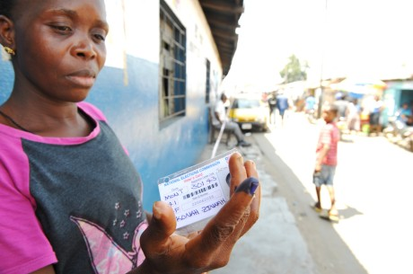

STRATEGIC PRIORITY IV: GOVERNANCE & TRANSPARENCY

The focus of Strategic Priority 4 is Governance and Transparency, aspiring to support the people in Liberia especially the vulnerable and disadvantaged, to benefit from strengthened institutions that are more effective, accountable, transparent, inclusive and gender responsive in the delivery of essential services at the national and sub-national levels.

Under this Strategic Priority Area, the UN will support the following PAPD priorities:

- Put in place policies, strategies, and programs that make Liberia a more capable state which

- will ensure i) a reformed public sector exhibiting improved fiscal discipline and service delivery, and a rebalance in the concentration of economic and political activities away from Monrovia, and ii) improvement in natural resource governance; and
- Reduce corruption which undermines the capacity of the state and increases the cost to deliver basic services. This will ensure a (i) more robust structures reducing waste and other systemic losses in the operations of Ministries, Agencies, and Commissions and (ii) Universal migration to ICT platforms and wider adoption of e-government to improve processes and productivity.

Pillar Four: Governance and Transparency
STRATEGIC PRIORTY Four: By 2024, people in Liberia especially the vulnerable and disadvantaged, benefit from strengthened institutions that are more effective, accountable, transparent, inclusive and gender responsive in the delivery of essential services at the national and sub-national levels
Output
Alignment to SDGs
Strategies

- A reformed public sector exhibiting improved fiscal discipline and inclusive service delivery, and a rebalance in the concentration of economic and political activities away from Monrovia
- More robust structures reducing waste and other systemic losses in the operations of Ministries, Agencies, and Commissions
- Universal migration to ICT platforms and wider adoption of e-government to improve business processes and productivity
Improved tenure and natural resource governance
Goal 1: No poverty; Goal 5: Gender Equality; Goal 9: Build resilient infrastructure, promote sustainable industrialization and foster innovation; Goal 11. Make cities inclusive, safe, resilient and sustainable; Goal 15: Sustainably manage forests, combat desertification, halt and reverse land degradation, halt biodiversity loss; Goal: 16. Promotion of peaceful and inclusive society for sustainable development, and building effective and accountable institutions at all levels; Goal 17: A successful sustainable development agenda requires partnerships between governments, the private sector and civil society.
4.1: Capacity of national and subnational institutions to formulate inclusive and responsive laws and policies for equal participation of men and women strengthened

4.2: Enhanced and strengthened capacity of the national and sub-national institutions to provide quality, gender responsive, equitable, client-focused and decentralized social and essential services.

4.3:1ntegrity institutions are strengthened at national and subnational levels to advocate and assertively implement policies, legal and institutional frameworks and practices that promote transparency, accountability and rule of law.

4.4: Citizens' awareness on ethics, values, principles, integrity and professionalism for national develop and national and subnational level s increased

4.5: Capacities of institutions to conduct of free, fair and transparent election Strengthened

In support of the above government priorities, and based on the comparative advantage of UN Agencies, the UN will focus on the following areas under Strategic Priority 4:
- Strengthen the capacity of national and subnational institutions to formulate inclusive and responsive laws and policies for equal participation of men and women;
- Enhance and strengthen capacity of the national and sub-national institutions to provide quality, gender responsive, equitable, client-focused and decentralized social and essential services;
- Strengthen the integrity institutions at national and subnational levels to advocate and assertively implement policies, legal and institutional frameworks and practices that promote transparency, accountability and rule of law;
- Increase citizens’ awareness on ethics, values, principles, integrity and professionalism for national develop and national and subnational levels;
- Strengthen the capacity of institutions to conduct of free, fair and transparent election.

Rationale for Strategic Priority 4
The Strategic Priority on Governance is modeled as a pre-requisite for the success of other three priority PAPD areas: Power to the People; Economy and Jobs, and Sustaining Peace. Good that ensures that the following is in place:
  - Respective policies, laws and frameworks;
  - Norms, values and principles that facilitate service delivery, rule of law, good governance and transparency;
  - Systems, Processes and Procedures;
  - Structures and Institutions;
  - Mandates, functions and roles of government institutions and partners for improved coordination.

The Theory of Change for governance and transparency, underpins the need for women, men, girls, boys and vulnerable groups ability to demand and benefit equitably from accountable and transparent delivery of essential services (at national and sub-national levels) with their views and perspectives solicited, respected and fulfilled; and that the state actors demonstrate strong political will to promote good governance and transparency; establishment and implement reliable policy, legal and regulatory framework for good governance; national institutions that are able to effectively and accountably deliver gender responsive essential social services at national and subnational levels. Additionally, for the public sector personnel to discharge their responsibilities in an efficient, accountable and transparent manner, requisite competencies are critical. The role of the civil society, community groups, women, men, girls, and boys, including the private sector and academia, will have the voice, space and participate in influencing the formulation of laws, policies and strategies and the delivery of essential services at the national and sub-national levels; the political leadership advocate and enable women and youth participation in decision making, security and political arenas; and legal and policy frameworks that promote gender balance in elections and politics; and strong values, ethics, norms culture at sub-national and national levels to inform decisions, and development outcomes and interventions.

Strategies for Strategic priority on governance and transparency
The following the UNSDF strategies for this strategic priority area:

Building a Capable State:
- Foster good governance and well performing institutions to create incentives for economic activities, good public services and play the key role in reducing poverty.
- Strengthen inter-ministerial coordination at national and sub-national levels. Strengthening intra-inter institution coordination and collaboration.
- Support establishment of strong institutions as they directly influence the way Government performs and its ability to achieve the SDGs.
- Promote South-South learning and knowledge networking.
- Support the Government achieve the core development objectives of the PAPD to generate shared prosperity, underpinned by strong institutions that promote equitable access to resources.
The Strategic priority on governance and transparency mainly focuses on the system strengthening and capacity building. The governance systems in Liberia has remained weak characterized by:
  - Exclusion and marginalization;
  - Lack of a common identity leading to ethic schisms;
  - Gender inequalities and imbalances.

2.3. Risks and Assumptions
The following are the critical assumptions and risks associated with the strategic Result Areas of the UNSDCF 2020-2024.
Fragility: The most critical risk with may affect the effective implementation of the UNSDCF 2020-2024. As a result of high vulnerability from over 14 years of war, poverty and low human and physical capacity, and a youthful population with very high unemployment rates, Liberia, though it has sustained peace since the accord in 2003, peace still remain fragile. The UNSDCF is premise that that Liberia will sustain the dividends of 17 years of peace. As mitigation measure, the UN will continue supporting the Government of Liberia through the strategic investments in capacity and system strengthening for sustaining peace and fostering long-lasting reconciliation and cohesion among the people of Liberia.
Changing Global Development Context. This risk relates to the shifting focus from countries seen to have moved from humanitarian context to development against these those that experiencing conflict and related emergencies. With the peace being experienced after the civil war and the recent Ebola outbreak, Liberia is experiencing declining development assistance from the traditional partners. The UNSDCF will however assume that the global development environment remains interested and committed to support planned development results in the and that the Government of Liberia will remain committed to the attainment of the SDGs, its Vision 2030, and the Pro-Poor Agenda for Prosperity and Development (PAPD). To mitigate this risk, the UN in Liberia, while maintaining traditional partnership with development partners, will adopt new innovative financing strategies including pooled funds and support development in the country. One such innovative approaches is the establishment of the Liberia Multi-Partnership Trust Fund (LMPTF) that was established in 2018 initially supporting peace building interventions and will be enhanced to eventually UN fund supporting joint of the UNSDCF 2020-2023. Moreover, the UN will create innovative and efficient approaches to reduce implementation and transaction costs through joint programming and common operational services.
Disaster preparedness: Liberia remains at a high risk country in terms of disaster in terms of geophysical, meterological, hydrological, climatological, biological, technological, environmental and manmade Risk of economic, health, environmental and social losses. The UNSDCF assumes that capacity for National Disaster Management Agency (NDMA) to coordinate both emergency preparedness and response. To mitigate this risk, the UN will continue to strengthen the national capacity to disaster management, contingency planning and coordinated emergency response should the need arise.
Gender Mainstreams: The UNSDCF is developed on the strong assumption, given the high gender disparity in most of the social, economic and political divide in the country, the Government will continue to mainstream gender into Peace infrastructure and other development sectors. This will entail the development and implementation of relevant policy and the legislative framework to pass requite laws that promote human rights, and advocacy by groups to lobby for macroeconomic stability and good governance, political engagement with the 2030 Agenda and the SDGs, favourable legal and institutional frameworks.

3. Common Budgetary Framework (TBC)
Approximately $ (USD) XXX is projected to implement the UNSDCF. Required and available resources to support implementation of planned outcomes are outlined in the table below. The funding gap is also indicated as resources to be mobilized. Funding will be realized through UN agencies regular, core and non -core resources as projected in agency specific Country Programme Documents (CPDs). Detailed annual Joint work plans identifying budgets, partner’s activities and geographical areas will be developed. The budgets are indicative and may change over time. These will be the basis for joint resource mobilization.
Resource Requirement for UNSDCF 2020-204 by Outcome (TBD)
Summary Budget by Outcome ( Strategic Priority Area
Outcome 1
Outcome 2
Outcome 3
Outcome 4
Total in USD

3.2. Resource Mobilization Strategy
Liberia is low income country with a population of 4.6 million and a Gross Domestic Product growth was forecasted to be at 3.2 percent in December 2018. Prior to the Ebola outbreak, Liberia economic growth stood at 7.5 percent but inclined to 0 percent after devastation of the virus, inclined in the cost of its major export iron ore and other economic factors. The Ebola Recovery Strategy was developed by the UN and Government to revive the economic. Real GDP growth is projected at 5.3 percent by 2023.
2018, a Common Country Assessment disclosed major challenges in various sectors. The need for the UN to mobilize resources to complement the Government’s efforts in addressing these challenges is paramount.
The Resource Mobilization Strategy seek to capture UN Agencies, Funds and Programmes resources to be mobilized for the next five years – by Projected and Resources to be mobilized – and a plan by which these resources will be mobilized. The strategy is anchored on the both joint resource mobilization and individual agencies efforts. For joint programming, a “One Fund” approach, aligned to the Liberia Multi-Partner Trust Fund which was established 2018,
The total estimated budget for this Liberia United Nations Sustainable Development Cooperation Framework is XXXX from with XXX fund to be mobilized and XXX is projected to be available fund. These funds will be mobilized from traditional and non-traditional development partners in addition to UN’s contributions.
 | Total | Projected As Available | To be mobilized
Pillar I
Pillar II
Pillar III
Pillar IV
Total USD

These indicative figures are further allotted by Outcomes (aligned to each outcome indicator) and Outputs in the Result and Resources Framework (Annex 1). Accounting for these resource will be done annually through a financial report which forms part of the Joint UN Annual Result Report.
- Implementation Arrangement
The UNSDCF 2020-2024 coordination(management) structure is guided by the lessons of the UNDAF 2013-2017 from the recommendations of the UNDAF End of Programme Evaluation and the Common Country Assessment. This includes the need to continued coordination, coherence and building and strengthening national ownership. It will ensure mutual accountability for the UNSDCF development results, and transparency in the use of resources in the most effective and efficient manner during the duration of the UNSDCF cycle. The coordination modalities are guided by the Paris Declaration, Accra and Busan Aid Effectiveness Agenda, and the UN Reform as approved by General Assembly Resolution A/72/L.52 on repositioning of the UN Development system.
The Joint Steering Committee
The Joint Steering Committee is the highest decision-making body of the UNSDCF 2020-2024 in Liberia. It is co- chaired by the Minister of Finance and Development Planning, the UN Resident Coordinator and a representative from the Development Partners. The JSC will provide high level policy guidance to the UNSDCF implementation, the Common Budgetary Framework, the Liberia Multi-Partner Trust Fund. The UNSDCF implementation will be coordinated by the Joint Steering Committee. The JSC will provide guidance on alignment with the PAPD priorities, allocation of the LMPTF (that will evolve into a One UN Fund for Liberia) resources and response to emerging issues.
Membership to the JSC includes the Ministry of Finance and Development Planning, Pillar Champions (Ministerial level), Ministries of Justice, Health, Education and any other as would be determined by JSC. The UNCT will be represented by the four Pillar Leads and the co-chairs of the IAPT on a rotational basis, OMT. The Resident Coordinator’s Office and the Ministry of Finance serves as secretariat to the JSC.
The UN Country Team
UN Resident Coordinator (UN RC) will lead the UN Country Team in Liberia implementation of the UNSDCF 2020-2024 under the umbrella of Delivering as One in line with the UN Reforms for an empowered UN Resident Coordinator. The UNCT is composed of Representatives, Heads or Country Directors of UN Funds, Programmes and Agencies, Non – Resident Agencies and the World Bank. The African Development Bank, IFC are also members.
The UN Resident Coordinator represents the UN in political dialogue at the highest level of leadership and in high- level policy fora. The Resident Coordinator is accompanied where necessary by respective Heads of Agency on policy matters related to their mandate. The Heads of Agencies represent the UNCT on policy dialogue at the Ministerial level on areas of their mandate. In the event of unexpected exigencies, the Resident Coordinator in his role as Humanitarian Coordinator will ensure swift emergency response and galvanize support based on the Inter- Agency Standing Committee Cluster approach.
The Resident Coordinator is supported by a strengthened Resident Coordinator’s Office that provides him/her strategic support in his functions in the areas of SDGs implementation, policy and programme coherence; communications, outreach, advocacy and partnerships, results-based management and business harmonization good offices, sustaining peace in Liberia
The UN RC in collaboration with the UNCT will lead the resource mobilization efforts on behalf of the UN Country Team. The UN Country Team will provide policy direction and oversight of the UNSDCF implementation to the respective Pillars through the Inter- Agency Programming Team, the Operations Management Group, the UN Communications Group and the UN Disaster Management Working Group. The UN Country Team will have regular meetings to ensure coherence, coordination, inter- agency collaboration and focus on achievement of development results efficiently. The meetings will also provide an avenue for dialogue, sharing of information and feedback to improve joint collaborative efforts, reducing duplication and strengthening focus on results.
The UNCT leads the UNSDCF programming, planning, implementation and reporting process based on mutual accountability for results including the SDGs and utility of resources, in line with the UN system wide reform. The UN Resident Coordinator (RC) accredited by the UN Secretary General, represents the UNCT and leads the strategic positioning of the UN system as the preferred and trusted partner to the Government of Liberia. The RC coordinates the UN development support in Liberia and enters into agreements with the Government, Donors and other counterparts on the UN Country Team
The UN Country Team will provide leadership to the UNSDPF Pillars, Inter- Agency Working Groups, Joint Programmes. The UNCT will designate staff for the inter-agency working groups and ingrate their expected results and achievements as part of their performance management goals to ensure their active participation and contribution to the UN collective effort. The UN Country team will contribute to UNSDCF planning, programming, reporting, monitoring and evaluation. The UN Country Team will avail the collective capacity of UN to support joint communications and implementation of the Joint UN Communications strategy for the duration of the UNSDCF 2020-2024.
The UNSDCF Pillars
The leadership of respective UNSDCF Pillars will be the Heads of Agencies who will coordinate and provide the strategic and technical leadership on the strategic Priority areas, and on joint Programmes including responding to emerging issues. The Pillars will be composed of Deputy Representatives, Senior Programme Advisors and lead technical experts in respective teams. They will be responsible for respective pillar results, programming, implementation, joint reporting and updating the information quarterly on UNINFO. The Pillar leads will bring to the attention of the UN Country Team policy issues that require UNCT attention.
The UNSDCF Pillars composed of UN Funds and Programmes including Non- Resident Agencies will be coherence to development programming and implementation in key areas of collaboration including advocacy, field presence, joint programming. They will ensure both issues based and mainstreaming of the key programming principles, especially LNOB and will ensure that this is reflected throughout programming. They will be accountable for the pillar results ensuring the UN delivers on its commitment in collaboration with respective stakeholders. The Pillars teams will be an integral part of the PAPD sectoral teams (based on the thematic and outcome areas) to avoid duplicated efforts and ensure alignment to the PAPD, building on synergy and ensure an integrated approach to development programming.
The Pillars meet quarterly to discuss progress towards results, effective programme implementation, coherence across Programmes, joint Programmes, field presence and local development, operational issues that affect implementation, monitoring and reporting. The Pillars are led by a Head of Agency with an alternate and the leadership is rotational (every two years), reporting to the UN Country team.
The chair will appoint a secretariat from his/her agency to facilitate the Pillar work.
The chair appoints a coordinator or secretariat
Representatives from the inter-agency working Groups including Monitoring and Evaluation and UN Communications are members of the pillar and will provide their technical expertise. The Pillars will ensure oversight, accountability, coherence on strategy, policy, programming, communication, advocacy and resource mobilization and reporting.
Inter- Agency Programming Team
The Inter- Agency Programming Team will lead the Inter- Agency Working Groups- Gender Working Group, Human Rights Working Group, Monitoring and Evaluation Working Group, the UN Communications Working Group and the Field Presence Working Group. These groups will provide strategic, technical and programming support to the UNSDCF Pillars and the UN Country Team in programming, implementation, joint monitoring, evaluation effort.
The IAPT will provide guidance on UNSCPF programming including, planning, implementation, monitoring, reporting, evaluation and knowledge management. The IAPT, co- led by the Head of Agency and UNDP will work closely with the OMT Chair/Co-chair, and RCO will identify emerging issues and bring them to UNCT attention. The IAPT is responsible for guiding the identification and development of joint flagship Programmes based on the outcome groups. Reporting will be through the UNINFO.
Joint Sector Working Groups
The Joint Sector Working Groups will be composed of combined Government of Liberia, UN, Development Partner, CSO actors aligned to the UNSDPF outcomes and sector areas. This will avoid duplication of plans, actors, promote coherence to UN support to the Government of Liberia, build on synergies and ensure integrated and complementary efforts to deliver development results.
The Operations Management Team
The OMT is led by the DRR- Operations - UNDP and the co- chair from an agency on a rotating basis. The Operations Management Team (OMT) will support increasing efficiencies through increased harmonization of business country process. The OMT is composed of working groups to facilitate harmonization and increased efficiencies- Procurement Working Group, Human Resource, Finance, HACT, One UN House.
The Disaster Management Working Group
The Disaster Management supports coherent UN response to emergencies in collaboration with the NDMA and other stakeholders. It provides technical guidance for UN contingency planning and preparedness and response. It is an Inter- Agency Team composed of members with expertise in emergency preparedness, contingency planning and response. They provide technical guidance to the UN Country Team.
Monitoring and Evaluation Working Group
The Monitoring and Evaluation Working Group supports monitoring efforts UNSDCF including sharing of agency-specific data collection, analysis and capacity development activities; and planning for management arrangements of the UNSDCF evaluation. It will provide coherent M&E advice to Inter-Agency Programme Team, Communications and Operations Management teams. The M&E Groups will offer technical assistance in the development of joint work plans, and joint programmes.
The M&E Group will promote agreement on data needs, standards and data disaggregation and will draw on expertise from across the UN system, acknowledging that agency-specific monitoring and evaluation requirements will complement UNSDCF-specific monitoring and evaluation work and works hand-in-hand with Data working group for the UNCT.
Joint GOL/UN Task Force on SDGs
This a joint Government and UN task-force responsible advising on the documentations and acceleration of SDGs in the country. The task-force will meet quarterly to take stock of the status of the implementation of the SGDs in Liberia. It should determine the linkages/alignment between the UNSDCF, PAPD with the SDGs as well as the annual reporting on the SDGs.
UNCT Partnership with Development Partners
The UNCT will hold two meetings annually with the Heads of Missions in Liberia to brief and update the development community on the UNSDPF and ongoing and emerging issues, share progress, discuss potential support for UN initiatives.
The RCO will have quarterly briefing technical meetings to provide updates on the UN reform, the key UN development in Liberia and key benchmarks of the UNSDCF implementation where UNCT will share innovative programming components during implementation.
The UN Country Team will have rolling costed Integrated Work Plans, including with multi-year initiatives for each of the Pillars, with indicators, and annual targets. The IWP will be developed in consultation with the Government of Liberia and all stakeholders and partners. It will be quality assured by respective Pillars and Working Groups to ensure coherence, and cross cutting issues are considered. The JWPs will have the budgets and expenditures, committed resources to ensure tracking of funding gaps and inform resource mobilization. This will be the basis for monitoring and reporting to assess the progress towards the UNSDCF. The IWPs will be reviewed, updated bi-annually with all stakeholders and reported at the JSC. The IWPs are flexible and will be adjusted to emerging issues.
Integrated Work Plans
The UNSDCF will be implemented though Integrated Work Plans for the four Pillars, including Joint Programmes, Flagship Programmes developed from the UNSDCF Pillars outcome areas before the rollout of the UNSDPF. The Joint Programmes will include two or more agencies as guided by the UN reform. The work plans will reflect the spirit of the reform and will build on synergies, coherence and complentarity for greatest impact demonstrating the collective work of the United Nations especially at the decentralized level. The Integrated Work Plans will be developed in collaboration with all the Government and other key stakeholders under the leadership of the UN Resident Coordinator. The Joint Steering Committees will provide oversight and guidance to the Integrated Plans.

5. Monitoring and Evaluation Working Group
Monitoring and Evaluation of the UNSDCF will be two pronged with a focus on measuring UNSDCF outcomes and impact, as well as measuring UNSDCF implementation against agreed upon results. The Monitoring and Evaluation plan of the UNSDCF will establish how:
- To generate information that will be used to assess the quality of the programs;
- To provide sound data and findings to inform decisions at implementation phase and.
- To coordinate monitoring and evaluation activities of the UNSDCF.

Key Monitoring and Evaluation activities of the UNPF will include:
- UNSDCF Final Evaluation: An independent and external final evaluation will be conducted to assess the relevance, efficiency, effectiveness, impact and sustainability of the UN System’s contribution, as described in the UNSDCF. The evaluation will be preceded by the necessary surveys or assessments comparable to the baseline, as outlined in the UNSDCF PMF and M&E Calendar.
- UNSDCF Annual Reviews and Annual Results Reports: The UNSDCF Joint Annual Reviews will be conducted under the coordination of the Resident Coordinator and the Joint Steering Committee. Annual Reviews will be a platform for UNSDCF outcome-level monitoring. The reviews will be an opportunity for the UNCT to engage with the Government and other partners to review overall progress toward results and take stock of lessons and good practices that will feed into the annual planning processes and commitments for the coming year. The UNSDCF annual review process will take a three-step approach:
Outcome Area Review: There will be periodic in-house annual reviews
- Joint Annual Workplans -level annual review process to assess the performance and contribution toward UNPF Outcomes/outputs, which will be facilitated by IAPT with support from the designated M&E Group members
- UNPF-wide annual review and consultation with the Government, which will be facilitated by the Resident Coordinator/UNCT.

Thematic group reviews: Thematic analysis of the UNSDCF will be done by the technical working groups under the leadership of the Inter-Agency Programme group (IAPT), including the Operations Management Team (OMT), UN Communications group (UNCG) and Monitoring and Evaluation (M&E) technical working groups). This will provide an opportunity to collectively assess convergence of participating Agency contributions and overall progress towards UNSDCF outputs and outcomes.
- The Pillars will have Quarterly and biannual progress reviews. Quarterly and biannual progress reviews are assessments pillars to monitor the progress towards the achievement towards UNSDCF outputs.
- Joint field monitoring visits with stakeholders and beneficiary representatives will be used for joint collection of field-level monitoring information (qualitative and quantitative) on results, processes and activities.
- The Calendar of major Monitoring and Evaluation Activities and detailed costed monitoring and evaluation plan are outlined in Annex 2 and 3 respectively.

- Communication of Results
This United Nations Sustainable Development Partnership Framework 2020 – 2024 will be have a Joint Communications Strategy to raise awareness, communicate results achieved, for advocacy and tell the narrative of the UN in Liberia. The Communications Strategy will drive internal and external communication through “Communicating as One” Lens.
The Joint Communications Strategy will be implemented by the UN Communications Group focusing on the following areas:
  - Enhance visibility, communication and Advocacy of the UN in Liberia through the New UN Sustainable Development Partnership Framework and the UN support to national agenda (The PAPD)
  - Increase the public and all stakeholders (GoL, Development Partners, CSOs, Private Sector, Citizens) understanding and awareness of the UN work in Liberia
  - Create public awareness of the SDGs and support the implementation and document the collective progress towards achieving them. Strengthen UN Advocacy, partnerships and resource mobilization initiatives.

Liberia United Nations Sustainable Partnership Framework
LEADERSHIP: CO-CHAIRED BY MINISTER OF FINANCE, UN RESIDENT COORDINATOR, WITH MEMBERS DRAWN FROM DONORS
Joint Steering Committee Including LMPTF
MEMBERSHIP:
- PILLAR LEAD MINISTRIES + 2. PILLAR LEAD AGENCIES (UN) 2. KEY DONORS 4. CSO
Liberia Multi-Partner Trust Fund
PAPD
Liberia United Nations Sustainable Partnership Framework
PAPD
Liberia United Nations Sustainable Partnership Framework
Liberia Multi-Partner Trust Fund
LUNSDCF
STANDING AGENDA AT UNCT: Pillar Meeting
Pillar I:
Power to the People
Pillar II:
Economy and Jobs
Pillar III
Sustaining the Peace
Pillar IV:
Governance & Transparency
CONVENOR:
GoL LEAD + HoAs
Inter-Agency Programme Team
IAPT Meeting Monthly
TWG Meetings
LUNSDCF
Pillar I
Sector Working Group
Pillar II:
Sector Working Group

Pillar III
Sector Working Group

Pillar IV:
Sector Working Group

MEMBERSHIP MAY VARY DEPENDING ON KEY DELIVERY

MEMBERSHIP:
From both UN & GoL
Monitoring & Evaluation Team
Members are represented at Pillar and Sectors Working Groups
DEVELOPMENT
PARTNERS
FRAMEWORK
UNSDCF
PRO POOR AGENDA
FOR PROSPERITY
& DEVELOPMENT
SDGs
(+Agenda 2030)

Annex 1: Liberia UNSDCF 2020-2024
Annex 2: Calendar of Monitoring and Evaluation Activities
Annex 3: Indicative Costed Monitoring and Evaluation Plan
Annex 4: UNSDCF Design and Implementation Arrangements

UK. Business Insider.com 2017 and Global finance (2018) Poorest countries in the world.
Liberia Central Bank 2018.
Africa Economic Outlook {Patrick Hettinger- AfDB; Moses Sichei- UNDP and Stanely Kamara- UNDP} (2017) Liberia.
World Bank, (2018). Poverty & Equity and Macroeconomics, Trade & Investment Global Practices.
World Bank (2018) The World Bank in Liberia. Overview.
Ibid.
One UN (2017) bid.
World Bank (2016) Liberia Education Sector Analysis.
World Bank (2016) Ibid.
World Bank (2016) ibid
World Bank 2018
CFSVA 2018
Ibid
Ibid
Ibid
UNDP/SCORE (2017).
Ministry of Finance and Development Planning, Liberia (www.mfdp.gov.lr/index/php/homepage.
OECD- Liberia (www.oecd.org/countries/liberia/42243397.pdf)
Republic of Liberia (2018) Project Preparatory Advance (IPFMRPII) FY 2017/2018 First Quarter PFM Progress Report.
Republic of Liberia (2014) Public Sector Modernization Government of Liberia.
Jones. N, Cooper. J, Presler-Marshall, E and Walker. D (2014). The fallout of rape as a weapon of war. The life-long and intergenerational impacts of sexual violence in conﬂict Overseas Development Institute.
UNDP (2016) Human Development for Liberia.
One UN (2017) CCA Thematic Paper on Gender
Human Development Report, 2015
One UN (2017) ibid
Ibid
Revised Gender Policy sited in the UNT- One UN (2017) CCA Thematic Paper for Gender.
Human Development Report, 2015
Ministry of Gender, Children and Social Protection (2017) sited in UNCT-ne UN (2017 CCA Thematic Paper Gender
United Nations (2016) Addressing Impunity for Rape in Liberia
United Nations (2016) ibid.
Ibid
UNMIL and UNITED NationsHuman Rights, Office of the High Commission (2015) An Assessment of the Human Rights Issues Emmanating from Harmful and Traditional Practices in Liberia.
Climate Change Vulnerability Index Scale (0-10) in which 0 is the worst performing measure and 10 is the best.
Ibid
Government of Liberia (GoR) (2017) Statement made at the Global Platform for Disaster Risk Reduction
Country Watch (2018) Liberia: Country Review
UN (2017) Sustaining Peace and Securing Development: Liberia Peacebuilding Plan
UN/GOL Vision Retreat Report; UN/GOL Strategic Prioritization Retreat Report
All Leadership Forms: (Informal institutions, CSOs, Community Based Organizations, Networks)
Pro-poor Agenda for Prosperity and Development Plan ( PAPD 2018-2023)
PAPD 2018-2023 pg 41
The main growth pathways are identified as: capital and labour intensive investment in infrastructure development, intensive research and extension services and remove constraints to raise food production in the ‘food basket’ counties by 25%, double acreage under palm cultivation using out-grower communities to boost export potential, value addition in agriculture processing to increase exports, special Economic Zones in development corridors to balance regional growth and attract Foreign Direct Investment (FDI)
https://www.afdb.org/en/countries/west-africa/liberia/liberia-economic-outlook/
PAPD 2018-2023 pg. 67
UNDP Report 2018
International Monetary Fund – World Economic Outlook

