Annex 3. UNCDF Strategic Framework 2018-2021: Pathway to gender equality and women’s economic empowerment

Figure 1. Pathway to gender equality and women’s economic empowerment

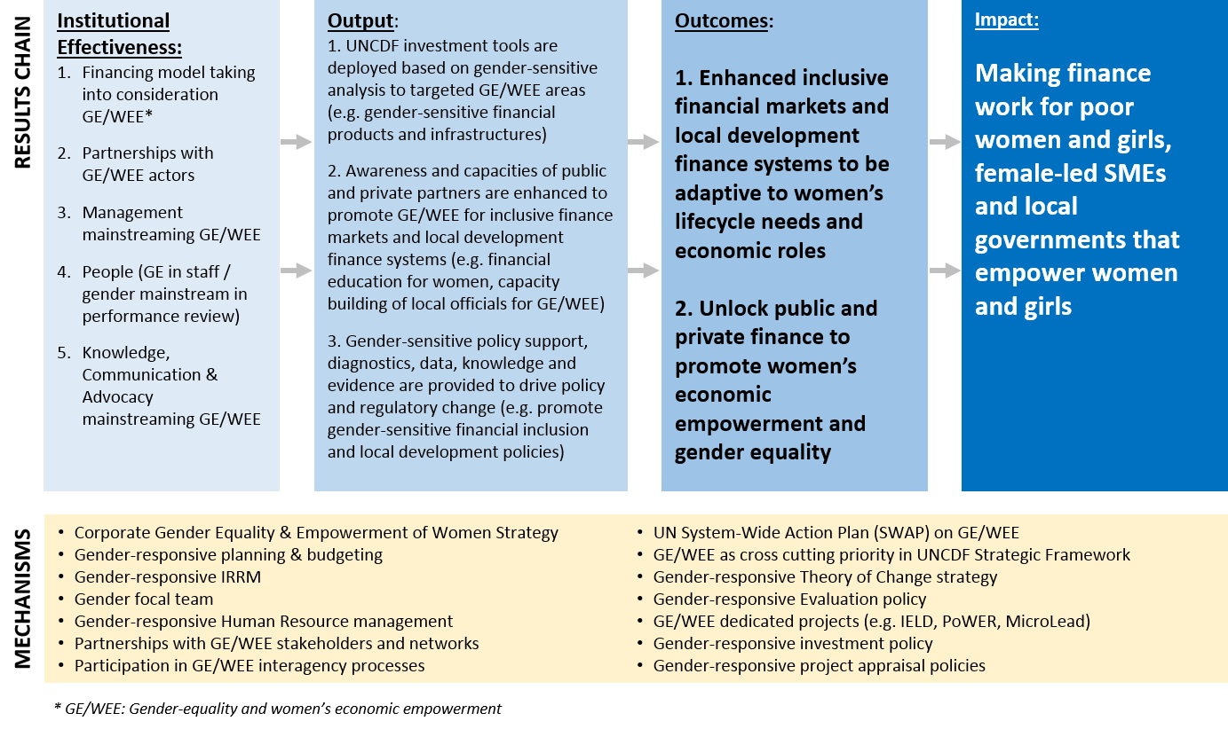

Pathways to Gender Equality and Women’s Economic Empowerment

Addressing gender equality and women’s economic empowerment is central to UNCDF’s mandate and is considered a cross-cutting priority area throughout UNCDF’s programmes and operations, per Figure 1 above. Furthermore, UNCDF applies a gender lens for product and channel development, investment, technical assistance to support the investment pipeline, policy support, and data to promote GE/WEE.

The transition from output to impact is identical to the change logic presented in Annex 2. UNCDF aims to make financial market systems work for women by expanding the supply of financial products targeting and responding to the needs of women and girls; increasing women’s and girls’ usage of and control over benefits from financial services; enhancing the enabling environment of policies and regulations that affect women’s access and agency in regard to financial services; as well as reinforcing the ecosystem support structures and networks to reach women and girls; and addressing elements of the socio-cultural context that negatively affect the supply, demand, and enabling environment for women’s and girls’ access to, usage of, and control over benefits from financial services.

In local development finance, UNCDF will promote the development of local government capacities to support gender-equitable local economic development by strengthening awareness of GE/WEE and participation of women throughout the mobilisation, allocation, investment, and transparency mechanisms. In particular, UNCDF will ensure women’s participation in the planning and decision-making of local development finance as well as guarantee that local investments target the local needs and roles of women and girls.

Coupled with gender-equitable systems change, UNCDF will also ensure the unlocking of finance and the flow of investments that engage women and girls. UNCDF will do this by de-risking and facilitating the development of relevant investment pipelines that benefit women in particular and that can attract additional resources for replication and scale.

At the impact level, UNCDF contributes to and benefits from extensive peer network research that indicates that systems change and finance unlocked for GE/WEE result in making finance work for poor women and girls, female-led SMEs, and for women’s financial agency at the local level in LDCs. This means that women and girls will have the ability to access and use financial products including digital financial services; will have greater voice and representation in decision-making in local government; and are able to benefit from improved financial and public-sector services and practices related to jobs and entrepreneurship opportunities. Furthermore, UNCDF’s technical assistance and policy advisory services will support legal and regulatory reforms in finance and local systems that empower women.

These end goals envisioned by the gender-responsive theory of change are directly aligned with the primary drivers of women’s economic empowerment that have been identified by the report of the UN Secretary General’s High-Level Panel on Women’s Economic Empowerment. Figure 2 below provides some illustrative examples of how UNCDF interventions line up with those drivers.

In addition to the results chain, the framework presented in Figure 1 also outlines the internal mechanisms that UNCDF has put in place to ensure it positively engages women and girls. UNCDF will continue to strengthen focus on updating and implementing a corporate gender strategy; monitoring compliance with the UN SWAP framework; and piloting of GE/WEE focused innovations in financial inclusion and local development finance to mainstream gender equality and women’s empowerment throughout its programmes and operations.

Figure 2. Examples of UNCDF’s alignment with the primary drivers of women’s economic empowerment

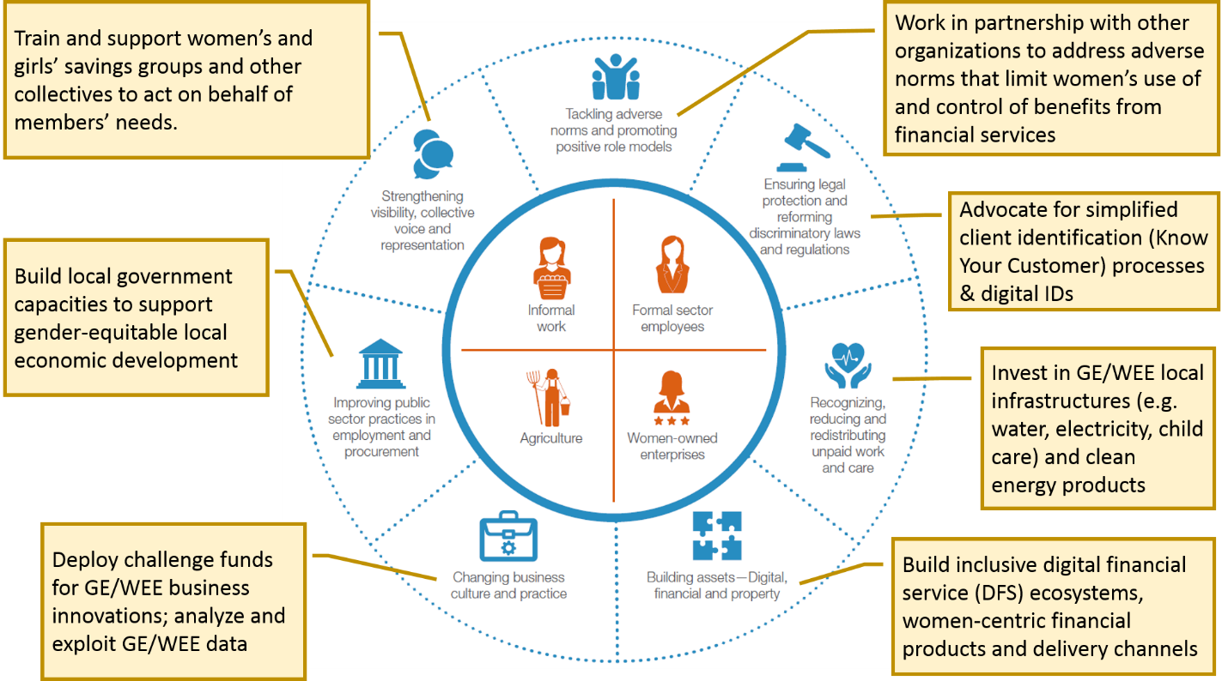

The GE/WEE pathway will be monitored mainly by the sex-disaggregated and theme-disaggregated indicators of the IRRM (see Annex 1) combined with evaluations and other programme reviews and assessments that examine contributions to GE/WEE. Building on data and evidence generated by the IRRM, evaluations, and assessments, as well as work with partners to understand the impact on the lives and livelihoods of women and their communities, UNCDF will also provide detailed quantitative and qualitative analysis of its progress in GE/WEE based on the gender-responsive theory of change in dedicated sections of the annual and cumulative reports to the Executive Board.

*********

UN Secretary-General’s High Level Panel on Women’s Economic Empowerment (2016) Leave no one behind: A call to action for gender equality and women’s economic empowerment. New York: UN Secretariat

